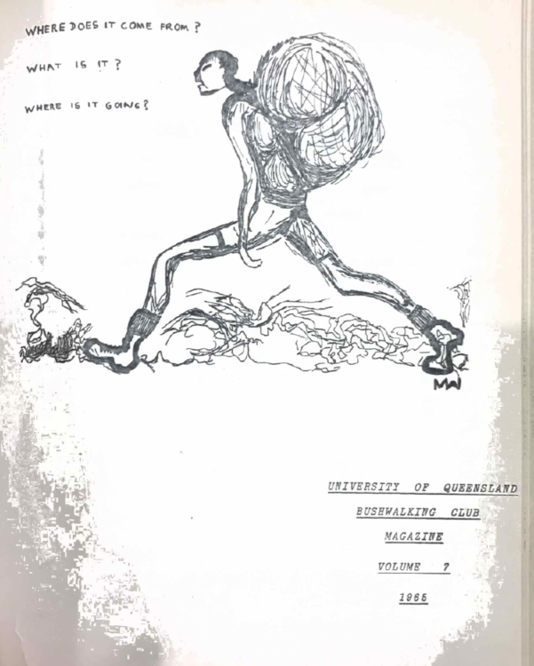

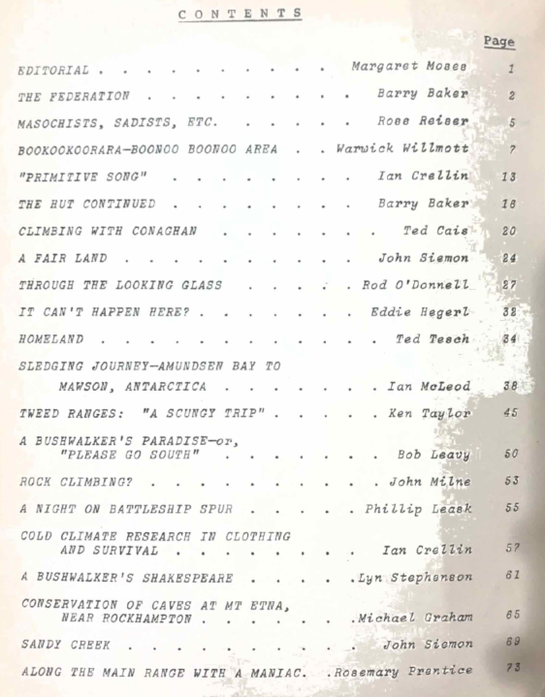

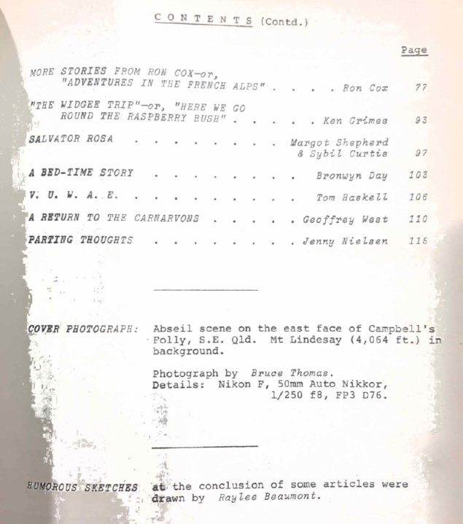

EDITORIAL
Margaret Moses
“Heybob” is growing! This year, following the examples of previous editors, we solicited madly for articles, and to our amazement found ourselves deluged with, not just articles, but lengthy articles, and cartoons! If this trend in verbosity continues next year, we may have to restrain such literary enthusiasm. Although one could happily read a 200 page “Heybob” unfortunately, the increased size would be too costly.
The production of Vol. 7 has been largely the efforts of Warwick Willmott and our typists, Mrs Inglis and Dorothy Linnegar. My thanks to them, the contributors, and everyone who helped.
The club now has a four-times-a-year, registered-at-the-G.P.O. circular which is called “Mini Heybob”; Vol. 1, No. 1 appeared in June this year. Besides notices of coming trips and meetings, “Mini Heybob” contains trip reports and news items. Life membership (legislated this year) entitles one (for a fee of 5 pound) to receive Club circulars (i.e., “Mini Heybob”) for a maximum period of 20 years. How about that!
The Club is an energetic and happy one this year as articles will testify. The love of the bush, appreciation of its beauty and peace, and the strong desire to ensure that there will always be areas free of man’s destructive ‘progress’ to which lovers of virgin countryside may retreat – these feelings, too, are evident in articles.
There are also accounts of trips where the purpose seemed to be not so much communion, as combat with nature. Certainly, the adventure, the challenge of a mountain, the physical exhaustion in reaching the peak, and the thrill of conquest are all important aspects of bushwalking – but these must allied to a sincere love of the bush, else they result in a purely masochistic approach. It is our tendency to be proud of pointless exertion that causes people to remark: “Don’t tell me you’re one of those mad bushwalking people!”.
As a Club (not necessarily as individuals), we appear to be fanatical and anti-social. If we really want to impress upon the “powers that be” that areas must be conserved, we should change our public image. No one is going to listen to a handful of cranks.

Please note that last year’s “Heybob” with cover photo of Hinchinbrook Island should read: Volume 6, 1964; not Vol. 5, 1964.
Readers are urged to patronize the firms who have given their support by advertising in “Heybob”.

THE FEDERATION
Barry Baker
On July 6th this year, eight bushwalking clubs of the Brisbane area voted in a Constitution forming the Queensland Federation of Bushwalking Clubs.
This idea germinated first, a couple of years ago, in the minds of two unconnected people, and for different reasons. Tom Young, President of the Brisbane Bushwalking Club, had considered the need for some organization to coordinate Search and Rescue operations, and thought that the best means to achieve this would be through a Federation similar to those operating in New South Wales and Victoria. Meanwhile, I had been concerned that little was being done to help upkeep tracks in National Parks or Forestry Areas, and also that somebody should be formed to supervise the placement of huts in the bush and generally make the stranger from interstate or overseas feel at home.
Late last year, I broached the subject to our committee concerning the convention of a meeting by the University Club of all the Brisbane bushwalking clubs. This idea met with their immediate and enthusiastic approval. Thus, in April of this year, a meeting of representatives from the B.B.W., B.C.B.W.C., N.P.A., B.B.B.W.C., and U.Q.B.W.C. (see conclusion of articles for abbreviations) was held in the Cellar of the Union Building at the University. This meeting was convened to endeavour to start some organization of these clubs which would have some jurisdiction over siting of huts and upkeep of tracks; and it was at this meeting that Tom Young suggested the best organization would be a Federation of Clubs which could then control other aspects, as well as those originally suggested (such as Search and Rescue). It was decided then to write to the N.S.W. Federation and request information concerning constitution and running of their organization. This was done, and a second meeting convened in May (again, in the Cellar) to formulate a constitution for Queensland. At this meeting three more clubs constitution for Queensland. At this meeting three more clubs attended: Y.H.A., Y.M.C.A., F.B.W.C. We spent much time defining precisely what we meant and wanted regarding various contentious aims in the constitution. In the section on government, we spent about two hours discussing the number of representatives per club – whether or not there should be proportional representation – the result being two votes per club. This meeting finished very late and cost 1/10/- pound for the extra time in the normally free Union Building.
Finally, we moved to the constitution and Inaugural Meeting held in July in the J.D. Story Room at Uni. There were many minor terminological disagreements which were eventually overcome. Following the formal acceptance of the constitution, office bearers were elected, results being: Barry Baker (U.Q.B.W.C.) President; Tom Young (B.B.W.) Vice-President; Peter Murphy (B.C.B.W.C.) Secretary; Stewart Patterson (F.B.W.C.) Assistant Secretary, and John Allpass (B.B.B.W.C.) Treasurer.
Following these elections, the fees due for the first year were discussed, and a fee of 5 pound, with a possible levy up to 5 pound, was decided upon, as expenses during the first year were not anticipated as being large. However, it was foreseen that any Search and Rescue organization would cost the Federation a large amount of money for gear, and it was agreed that any such material should be collected slowly over a number of years.
After this, we elected Edgar Kemp (N.P.A.), Stewart Patterson (F.B.W.C.), and Graham Jurott (F.B.W.C.) as Trustees of the new Federation. We then moved onto the subject of Search and Rescue, for which an investigatory committee was formed to probe the resources needed for such a venture.
So much for the accurate reporting of past history. I should now like to move to the far more nebulous aspects of the future and what it holds for the Federation. This Federation has been envisaged as a voice of the combined bushwalking force of Queensland to strive for their ideals and rights, and as such, it can hope to wield far more weight than any of the organizations could separately. It also has some contributions to make to the member organisation, such as in Search and Rescue. It is planned, eventually, to have a core of ready volunteers, backed by sound equipment, for use in any bush or rock emergency; this will, of course, not take place immediately.
Also, functions of the Federation will include advice and policy on the siting of huts and tracks and their subsequent upkeep. This is a very serious matter indeed, when half of the walking tracks in Lamington National Park are overgrown, washed away, or unable to be found. Huts and their upkeep will probably always be a contentious problem, with many saying they are not needed in “Sunny Queensland”, or that they encourage louts. I disagree on both counts. Queensland can be a very inhospitable place, even in Summer, and louts are never likely to expend energy needed to attain places where huts are likely to be built. Also, the idea of a Hut Committee is to limit the huts to places considered absolutely indicated, so that indiscriminate hut building will not take place – this will ensure that there are always some wilderness areas.
It is hoped that the Federation will spread from the Brisbane area to engulf the whole State’s bush clubs, and it is confidently seen that the Federation can do much good for its member organisations and the cause of the bush in general.
Abbreviations
B.B.W. Brisbane Bushwalking Club
B.B.B.W.C. Binna Burra Bushwalking Club
B.C.B.W.C. Brisbane Catholic Bushwalking Club
N.P.A. National Parks Association of Queensland
U.Q.B.W.C. University of Queensland Bushwalking Club
Y.H.A. Youth Hostels Association of Queensland
Y.M.C.A. Young Men’s Christian Association
F.B.W.C. Bushwalking Family Club

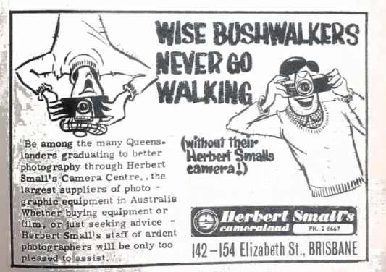

MASOCHISTS, SADISTS, ETC.
Ross Reiser
1. In the beginning was the mountain, and on this mountain was builded an hut; and the name of the mountain was Mount Barney, and the hut which had been builded thereupon was called “The Hut”. Now, “The Hut” had been builded by a tribe of Arabs, and they were called by the name “Bushwalker”.
2. “The Hut” was of a shape most wondrous strange, weird beyond the signing of it; and the people came unto “The Hut” on holidays – even on the Sabbath, and on the Sabbath-minus-one.
3. And sacred rats lived in “The Hut” and they waxed strong and fierce, and guarded the hut well; and people came to love the hut, for it served them well.
4. But there arose, among the elders of this tribe, one who loved not this hut, and he was called Old Man Tesch, and his fame was great throughout the land, for he builded great buildings.
5. And he spoke unto the people, saying,
6. “Let us hasten unto the mountain, and destroy this hut and there let us raise up a glorious edifice in its place.”
7. But the people replied unto him with an unequivocal, and unbiblical “Nuts”.
8. Whereupon Old Man Tesch, caused the people of the tribe to be cast into slavery, and he caused them to labour on the task which he set them.
-- which is about where I come into the picture. A friend of mine, Warwick Willmott, just happened to mention that there was a trip up Barney in the Christmas Vac. – spot of building going on, alterations to the hut, etc; should be fun, like to come along and help? Well, anything for a giggle, so I toddled along.
The thing even started badly; this native guide bloke Warwick had arranged for us, got us bushed getting to the place; practically no sleep the Friday night (actually, Saturday morning). Arrived late at the start point later on the morning, just in time to appreciate the full effects of the morning heat. Here we met the roofing materials we were to carry to the top. Con-man Willmot (a cousin of his is a member of a most successful press gang) had said it was light and easily carried.
Light it was, but Old Man Tesch had excelled himself in the sadistic potential per gram weight which he had managed to pack into these sheets. They were of a strength, you understand, calculated to make rolling them a desperately hazardous operation. I have no figures to hand on the number of broken arms, crushed fingers, etc., suffered but I should imagine that the casualty rate must have been something pretty fierce. Then there was the exquisitely fragile string for the tying of them. One never quite knew when a string might snap and a “loaded” sheet spring flat. The length was just optimum, calculated to catch on alternate obstacles, sufficient to allow the labouring slave to make progress, but only with one –uva* struggle.
Well, we made it to the top, just the odd spot fagged out. It was not so much that the brow was wet with honest sweat: one felt one had been swimming in a sea of it for the last couple of hours, and if you have ever gone for a swim complete with pack and roofing, you will know just how riting it can get. At the top we handed over our wearisome loads to some birds (for which, incidentally, this bushwalking caper is strictly) who carried the rubbish to the building site.
That night it rained.
I lay in our spacious tent (“You breathe out, while I breathe in”) listening to the rain pitter-patter gently onto the canvas, and feeling it seeping through soaked sleeping bag, onto damp feet. As I tried to stretch a cramped appendage (“Don’t move or you’ll have the barned thing down”) I came to the conclusion that bushwalkers were a bunch of masochists, sadists, and steaming nits, and swore I’d never be party to such pointless exertion and discomfort again.
… but it’s like the man says, the memory is short on the but-busting slog, but disconcerting long on the satisfaction of having made it; so I guess if there is a spare seat on the ‘bus to Barney this Christmas, I might just wander along, realizing all the while that the whole shooting match is just so much nit-wittery.

* Insert suitable word starting with heck.
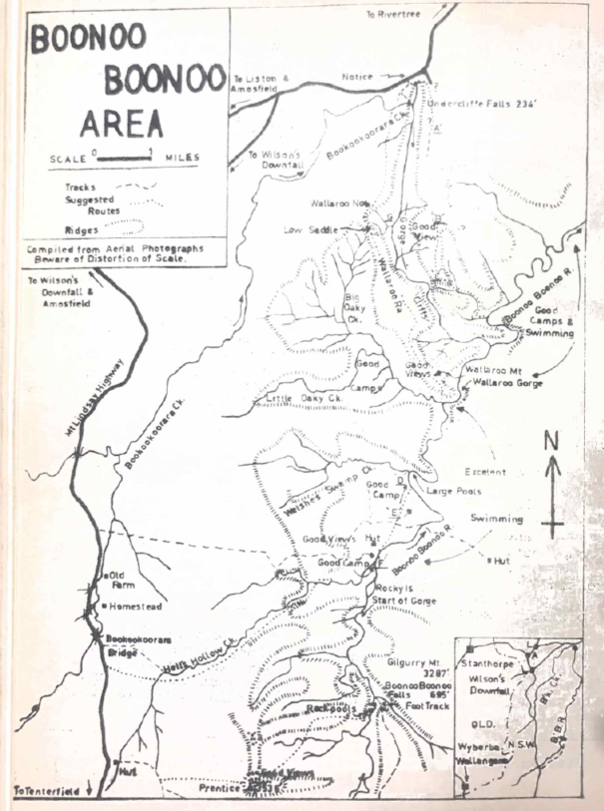
BOOKOOKOORARA-BOONOO BOONOO AREA
Warwick Willmott
Although a somewhat light-hearted article concerning this region appeared in last year’s magazine, further trips to the area and numerous enquiries have prompted me to write a rather more factual account, to serve in the future as a guide for private and club trips.
Location and Maps
The area is situated about fifteen miles south-east of Stanthorpe, eat of the Qld-N.S.W. border, and east of the Mount Lindesay Highway. The southern portion is adequately covered by the Drake 1 inch to the Mile military map available from Watson, Ferguson and Co., South Brisbane, but the northern section is included on a map which has not been published. Lands Dept Parish maps are available from Sydney, but these are relatively useless. However, Paris of Bookookoorara, County of Buller is one sheet that may be handy.
The best solution to navigation problems, however, is provided by the serial photos of the area. These can be obtained from the Dept. of National Mapping, Derwant House. University Ave., Canberra, the most useful photos being Warwick 4 mile, Run 6, photos 51 and 53, Run 7, photo 34. It is to be emphasized when using these photos, and also the accompanying map which was taken from them, that owning to distortion, the scale varies over the surface of a photo.
Geology
The region is exclusively ‘Granite’ although there is considerable compositional variation over the area. A recent account of the area should be appearing soon is “The Geology of New South Wales”, published by the Geological Society of Australia.
Vegetation, etc.
The hills in the area are reasonably open grazing country, with good timber. There is hardly any troublesome undergrowth, and the walking is easy. On the creek and river flats there are large green, grassy areas, suitable for bare feet. The Boonoo Boonoo River alternates between clean, rocky slabs and deep, still pools.
Access to the Area
By car, via either Rathdowney, Woodenbon, Legume, and along Mt. Lindesay Highway to the village of Liston, or via Warwick, Stanthorpe, and east across the border to the villages of Amosfield and Liston. The former route may be quicker and shorter, but some of the road is gravel, and the longer route may be preferred. Depending on where one intends to start walking, there are, from here, a number access routes to the most interesting parts of the area.
- Drive east from Liston along a gravel road signposted “Rivertree, Undercliffe”. At the three mile point, a road comes in from the right. At five mile point, just past some cattle yards marked “Undercliffe”, on the right side of the road there is a crude sign saying “Undercliffe Falls”. A rough track, O.K. in dry weather, takes you 300 yards to the top of the falls which are quite spectacular, particularly in a wet season.
- Drive south along the Mt Lindesay Highway and continue 6-7 miles past he village of Wilson’s Downfall. On the left hand side a rather definite gravel road branches off and runs parallel to a fence. This track rapidly deteriorates, and later on is suitable for four wheel drive vehicles only. Start walking whenever you feel like it. The track will take you to the central part of the area, to the Boonoo Boonoo River, good camping spots and swimming holes.
- Drive south along the Mt Lindesay Highway to the Bookookoorara Creek bridge. Leave the cars here wherever convenient. Walk south along the road for a few hundred yards to a pipe culvert, head east up a small creek, over a hill, and into a swampy area. This is the headwaters of Hell’s Hollow Creek, as shown on the Military Map. Follow this creek on the right side till it plunges into a steep gorge. A couple of good waterfalls are reputed to be here. Continue down the creek until the Boonoo Boonoo River is reached.
- Drive south along the Mt Lindesay Highway until the village of Boonoo Boonoo is reached. Continue north-easterly along a dirt road to Boonoo Boonoo Falls. This route is not recommended; the road is revolting, and is only useful if one wishes to have a quick glance at the Falls.
Walking
The shape and position of the area almost decrees that this region would be most enjoyed by throughwalkers, although a successful basecamp can be held. A combined throughwalk and basecamp would be even more successful. Also, due to the size of the area, one is limited to three and four day walks; a two day weekend trip would be pointless, as it requires a good three quarters of a day to walk in and out.
Below are some recommended trips (points C, D, etc., refer to points marked as such on the map).
4 day throughwalk (a)
Start off from Undercliffe Falls, cross over to the eastern side of Bookookoorara Gorge, and walk south along a flat topped ridge, keeping the gorge dimly visible through the trees on the right. At approximately point A, a rough vehicle track should be met, also running parallel to the gorge. continue along this track until point B, where the gorge swings towards the east. Form here excellent, sweeping views towards the sough, east and north-east, should be obtained; impressive, if you remember not a sign of habitation can be seen anywhere. This may be a good place to eat lunch. Leave the track here, and continue down a steep ridge to the south-east. To the south, good views should be obtained of the cliffs of the lower section of Bookookoorara Gorge. At point C a fence is encountered, and the ridge suddenly drops off into a gully. Skirt to the left and drop down into the small creek. Follow this creek north-east until the Boonoo Boonoo River is reached. Depending on time, pick a camp spot for the night – there are plenty available.
Next day, continue south along the Boonoo Boonoo, swimming at will in many of the pools. Wallaroo Gorge will be interesting, being quite rocky, but may be difficult to walk through in wet periods. (If cars have been left at Undercliffe, walk like blazes, and try to reach point F to camp for the night. It is advisable to take a short cut across a series of low ridges marked E). if time permits, climb Wallaroo Mt. for some good views; then one should be able to camp at point D for the night, quite a good spot.
Next day, continue up the Boonoo Boonoo until a gorge starts to develop. Walking is now difficult in wet or even normal conditions; it may be easiest on the eastern side. Eventually, the Boonoo Boonoo Falls are reached, these being 695’ high, and spectacular at any time. To climb to the top, there is a graded walking track to the left, starting from an obvious rocky ridge one third of the way up the Falls; a slower party could camp at the top of the Falls. Although there are excellent swimming holes, campsites are small and uninviting, but do exist. (The party walking like blazes should be here at lunch time).
From here, head west up a ridge from the Falls, cross over a shallow, swampy valley to the left and climb the northern slopes of Prentice – a dome like mountain with bare, exposed sides of rock, very similar to Wyberba. From here, one can see across to Lamington, Mt Lindesay, Mt Barney, Mt Superbus, and maybe even Cunningham’s Gap.
Now, march westerly back towards the road. The country is so confusing here, it is best to just use a compass bearing. The fast party can camp the night at Bookookoorara Bridge, and hitchhike or walk back to Undercliffe the next day. Hitchhiking on this road is not all that good, by the way. The slower party can get to the road sometime in the afternoon, to where some kind person has brought their transport.
4 day throughwalk (b)
Start at Undercliffe but, instead of keeping to the easterly ridge, try the western one. Walk to Wallaroo Knob, and then easterly along the Wallaroo Range. Good views should be obtained. Drop down into the Boonoo Boonoo River for the night, and then continue as above. Alternatively, there are excellent camps in Oaky Creek if one doesn’t feel inclined to walk all the way along Wallaroo Range.
4 day throughwalk (c)
Start at Undercliffe, and try walking down Bookookoorara Creek; may prove to be a trifle slow, due to extreme rock nature of the gorge, but has been done. May be impossible in wet weather. There is a huge, deep rock pool at point G. the lower Bookookoorara Gorge is hemmed in by cliffs and is most impressive. After reaching the Boonoo Boonoo River. Continue as above.
3 day throughwalk
Camp the night at Undercliffe, and have a look at the Falls. Then drive south to the Bookookoorara Bridge, and walk in down Hell’s Hollow Creek, as described previously. Quite an interesting small gorge is developed here. Next day can be spent lazily swimming, but in the afternoon walk to the Boonoo Boonoo Falls and camp at the top. Next day, walk back to the road over Prentice.
3 or 4 day basecamp
Camp at Undercliffe the night, say farewell to the throughwalkers, then drive their vehicles to Bookookoorara Bridge. Walk down in Hell’s Hollow Creek. Basecamp somewhere on Boonoo Boonoo River, and fill in time by visiting the Falls and swimming holes. Walk out along track to be found on ridge marked E, which is the track mentioned earlier, joining the main road north of the Bookookoorara Bridge. Good views can be had on this track. Some basecampers may like to turn into throughwalkers by walking out over Prentice.
Finally, all this rather garbled information was compiled in the hope that other individuals and clubs may realize that there are worthwhile bushwalking areas, apart from the old favourites of Lamington, Mt Barney, and the Main Range.
Also, if you become lost, don’t worry; that is half the fun of the place.

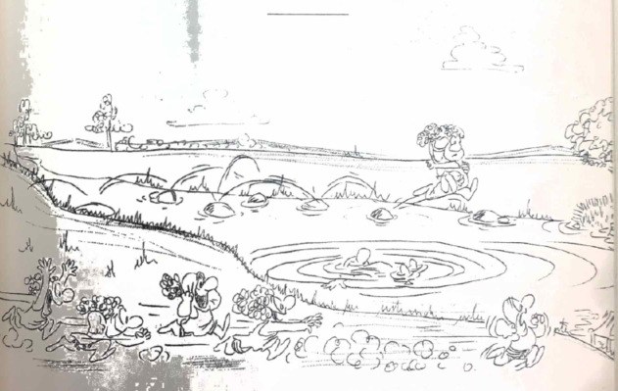
“PRIMITIVE SONG”
I. Crellin
The folklore of the hills is unique, and of special note is the music of the area. Our research team has uncovered one such song sung by the backwoodsmen of Southern Queensland, but probably its origin goes back further to the itinerant visitors who crossed those hills, carrying large bundles on their backs and singing strange chants as they marched. Our man recorded one such song which was sung to the folk tune of “Hi Ho! Sing Rolly”.
It went as follows –
Verse 1.
A is for abseil down steep rocking cliffs. Hi Ho sing Rolly.
It’s not for long life, we’ll all end up as stiffs, with a rollidy pollidy, hollidy bollidy. Hi ho sing Rolly.
The verse continued with the insertion of the second line
Hi Ho sing Rolly
And the fourth and fifth lines of
“With a rollidy pollidy hollidy bollidy, hi ho sing Rolly!”
The first and third lines then went in alphabetical progression until Z was reached.
B is for billy, all covered with grime, our mentality’s such that a clean one’s a crime.
C is for compass, wet or dry card, with either you’ll find getting lost is not hard.
D is for daylight which always goes quick when lantana begins to get hick.
E is for Elephants we see in the scrub, if the colour is pink, give your eyes a good rub.
F is for Fizzy whose praises we shout, it raises our spirits and is good for our gout.
G is for Grimes all covered with hair, he wants his degree and wishes he were there.
H is for Hell, where good bushwalkers go, it’s a good walking country but the water is low.
I is for Injuns which we never meet, but the Brisbane Bushwalkers, they’ve got us beat.
J is for Jellybeans, a cooking good food, but if there’s nowhere to cook them, it’s really quite rude.
K is for Kilt, dress-like affair, it’s a part of the gear Scottish bushwalkers wear.
L is for Lantana, it’s really a rot, if you don’t shed some blood then you bloody well aught.
M is for Meetings, clear thinking abides, to hell with the minutes and let’s have some slides.
N is for Napoleon, terror of war, when the wood’s all wet, it’s what we wish for.
O is for O’Donnell, the Secretary man, if you want to know something then he’s got the plan.
P is for Porridge made of rolled oats, what’s your favourite chunda? It’ll get our votes.
Q is for Quid, like we haven’t god, we’re a poor but happy, miserable lot.
R is for Ridges with sides so steep, when you find it’s the wrong one you really could weep.
S is for Sybil, our bug collecting gal, she’s quite a success, she attracts them so well.
T is for Time, but bushies know naught, it’s “disturbing the peace” if ever we’re caught.
U is for Up, where we always go, they like it that way for going so slow.
V is for Valley, oh what a slog! It’s wet down the bottom, oh what a bog!
W is for Warwick (this may frighten you) for there lives Don Hitchcook, so we’ll drive straight through.
X is for xylophone, bring it along, but to take it up Barney, your head must be wrong.
Y is for Yiddish, the speech of the Jews, a strange foreign language where “Heybob”s abuse.
Z is for Zeehan on Tassie’s fair Isle, we’re all mad enough to go there a while.
Of course after this, they start on the second verse from A to Z, but, due to the shortage of time, space, and brainpower, and the fact that the tape recorder ran out of tape at the crucial moment, we will not be able to publish before next year’s “Heybob”.

THE HUT CONTINUED
Barry Baker
As it is written in the prophets, behold, I send my messenger before thy face, which shall prepare thy way before thee.
St. Mark
So the Hut, as Rosser said, was burned, bashed and buried, ironically, all in the reign of Mungo Scott (no wonder the old man has not been walking since; rumour hath it that he is hiding away composing “Ballads of a Bush Hut”). The news leaked out slowly at first, with the early rumours of Ted Tesch on Barney being countered by tales of his sightings in Queen Street. However, at last the dreadful tidings were proved by visits to Barney where the Hut, sadly to lament, was even more dismembered than ever previously.
This scene was in the winter of 1961, almost a year after “Architecture and the Barney Hut” appeared under the signature of Tesch in U.Q.B.W.C. Magazine (as Heybob was then titled). In this historic and again prophetic article, a very rebellious Tesch had offered gelignite, if only one support, but alas (!) none were forthcoming (apathy or pride?). So, he took it upon himself to reduce the labours of many, and in their place erect almost singlehanded a building of the space-age (or maybe only of the Victorian age) – an inverted saucer. (Heaven knows enough tea went into the builder). The new hut had to be of local material, so there was no need for the rafters and other man-made pieces of wood hauled there at great pains by earlier members (Phillip Smith’s articles testifies). These were burned slowly to ward off the winter cold, and brew the tea. While building the hut, Eddie lived in a very small rectangular humpy building with a sliding door – very musical in the middle of the night (oh, those cps of tea!!) – and used to visit the big Metropolis once a week, on Thursdays, when he had a certain one-way lift; this was provisions day, and also contact time for world events. During his stay of months on the mountain, Eddie earned the admiration and amazement of the local farmers, one of whom one day delivered a “phone message by climbing half-way up Peasants’ Ridge. This hut, while being mainly Tesch complete, had small splashes of others – notably Doug Clague, who religiously climbed the South side for many weekends – I suspect, mostly for the pleasure of smoking a communal pipe, others who visited the peak were, from time to time, conscripted, and I can remember helping Norward Harrison and Ian Curry to increase tension on the superstructure one very cold August weekend.
This hut was finally finished by the after-exams trip when everyone crowded into the small space and found to their horror that the chimney, unfortunately, was no better at all. The shape was better, sure, but when I stood up the roof, of course, was dented (cement is harder than aluminium, you galah!).
And so, peace again reigned in the saddle – no silence shattering aluminium; no racoons laugher, and no gentle strains of Beethoven’s “Ode to Joy” wafting on the winter gale down the Gorge. Building ceased, and in fact the only “improvements” were made by Lucy Harrison who bought a wooden window and installed same so that she could view the Gorge from the safety of the hut. She then had to hide to claim from the Club – I must have been made; I remember voting her the money.
The peace lasted three years almost to the day, when, in late June of 1964, I noticed on one of my trips that there was a small three0-cornered tear in the roofing on the Eastern side. One month alter this was larger, and by the end of October large sections had been removed – not, mark you, by the hand of man, but by nature – strong, but by now not silent. Shades again of the prophet witness Duncan McPhee’s “Epitaph of a Hut”. These signs sparked off a very lively meeting of the committee and other concerning future plans. Once again, with eloquence and minute plans, that father figure, Tesch, romped home with a design to last fifteen years (the former had been to last indefinitely!). Facts and figures followed furiously. Should we pull the whole structure down, or should we build around? Most people including the builder, felt that the structure would not last much longer despite the fact that I, with all my weight, had romped gingerly over the rafters and found them more solid than I had expected, and probably fit for many years. However, the decision for a brand new roofing section was carried and the donations poured in, 40 pound being promised on the spot. Then the job of carrying cement, wood and aluminium was broached, and would we need any sand? The sand proved to be readily available on the spot with the great assistance of summer storms; the other items were much more difficult.
Owing to the time of the year, there were only the old lags who had any spare time; this meant that 220 lbs. of the 300 lbs. of cement were carried up South Ridge on hot, summer days by a demented, but dedicated, bushwalker. The remaining cement was transported by unsuspecting friends (that line only worked once for, like Banjo Paterson said: “The word had passed around’); and some by Tesch on his way to the top to fix the supports for the superstructure. I well remember the first 60 lbs. when, after a very hard week’s work terminating midday Saturday, I was staggering up Peasants’ Ridge when I fell into the Wests (father and son) who, naturally, thought I was demented; there were to be many times in succeeding weeks when I agreed. About this time, Tesch coaxed Mungo Scott into donating himself and his landrover to transport aluminium and pre-cut rafters and supports to the Washway on the way to Peasants’. Eddie really must have kissed the Blarney Stone, or maybe the ballads are soothing!
This transport effort was in preparation for the grand onslaught by the plebs on the after-exams trip. People turned up in scores and a “bucket”-brigade was organized to shift wood up the slope in relays. The aluminium was transported up by giving pieces to people to carry. Now, for those uninitiated, aluminium comes in 6 ft. by 3 ft. sheets and belies its name, as it is heavy. Most groups organized themselves into two and carried them tandem style. However, yours truly had foolishly promised to carry some up when he came down after work. Tesch, obviously with a mind for all the cement and his rapidly tiring mates, left five sheets of aluminium and a few pieces of very weak string. I found the only way to roll the sheets was to jump on them form a great height (mine) and by this method they would stay partly rolled – incidentally, got my own back; Tesch spent some time straightening them out again. Then, tied onto my pack, I was off to tackle the hill. Three steps, and disaster! The string broke, and this repeated itself until I used the straps of my pack (must remember to write a free ad. for Mountain Mule). Met Barry McCann and Patty Costello who were cheerful and said I would never make it; but spurred on by the mist, rain, and by now, darkness, the trip from the Washway was done in 2 hours 5 minutes with much cursing and many lopped trees, a very dispirited body and some bent aluminium. I shudder to work out the foot-pounds of work for comparison with Egypt!
The next day saw the structure of the hut erected, and the succeeding weekends of work by Eddie, Dennis, and others the succeeding weekends of work by Eddie, Dennis, and others saw the hut in its present form. Then came the first picture shown at Freshers’ Welcome this year, which displayed all the red variations; this sent Tesch berserk and he rushed off to paint the hut in more peaceful tones.
At present, the third edition Barney Hut has more head space, more light, and probably more strength; but the smoking is not improved and still the dissenters dissent and the protagonists assert. There is even another, even more philosophical article by Tesch in this Heybob, striving once again to put his theory of an Artificial in harmony with a Natural. This, incidentally, McPhee was also doing in his very succinct (for him) article in 1961, and many of his questions again apply.
And now for prophesy (by now, traditionally), the final word. I feel that Mungo’s fears will never be repeated, and that the fate of the Hut will reset with the Barney Monster with his powerful elements of fire and wind. And also, shades of the future, I see further hurts and further disagreements, not necessarily only at the present site.

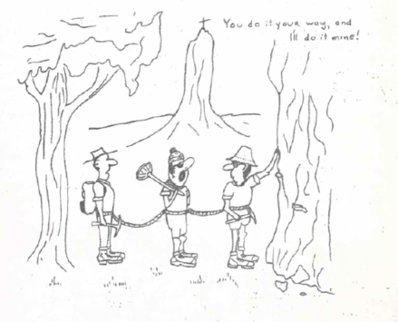

CLIMBING WITH CONAGHAN
Ted Cais
Pat Conaghan, one of the veteran climbers of the club, added a new first ascent to his long list this year, with his climb of the bare north-east buttress of Tibrogargan. This climb was one of the first to necessitate the use of expansion bolts or plugs for progress, and it was the thought of the pleasure of climbing such a route that lured me into the party that Pat was organizing for the second ascent. Actually, only two of those whom Pat had invited could make it; John Tillack, an honours Chemistry student, and myself, a first year student.
The three of us set off early on the morning of Anzac Day in Pat’s VW and, although the weather looked threatening, we were hoping that it would clear by the time we had reached the Glasshouses. I had rather foolishly told my parents that I would be home by eight o’clock that evening, not being able to foresee the rather eventful time that was in store for us.
About eight-thirty that morning we started the climb, and, although the rock was greasy from a recent shower, we decided to give the first few pitches a go while waiting to see what the weather would do. Pat, therefore, climbed up to the first stance, which was in a timbered gully about fifty feet up, and belayed me up to him. While Pat prepared for the next pitch, John, who was climbing last, joined me in the gully.
Although the weather still looked doubtful, the roc above us was quite dry, due to the strong south-easterly wind which was blowing, and so we resolved to continue with the climb. Pat climbed diagonally to the right now, around a steep buttress and up to the second stance, which utilized a bolt belay. After three more pitches, two of which were fairly difficult, we gained the bottom of a steep gully, which was more than half up the buttress. Above this gully rose the blank wall, which we would have to climb artificially.
We had been so preoccupied with the climbing that we did not notice the rain blowing in off the sea, and the first rain started falling while we were preparing for the next pitch. However, the shower soon passed, so we had our lunch while waiting for the wind to dry out the rock. After half an hour, we were able to carry on, and Pat gathered his etriers for this next pitch. John belayed him this time, so that I could stand back a little, and watch Pat climb. He climbed free for about fifty feet on steep, sound rock, and clipped in to a bolt at the bottom of the last thirty five feet, which were entirely vertical and almost holdless. It was here that Pat had spent many days drilling the rock to set his bolts; a very laborious task. Now all the bolts were in place, and soon Pat, who is an old hand at artificial, had reached the belay ledge above this pitch. I went up next, and had to make a little detour to free the haulage rope down which Pat had sent the etriers, since it had become tangled in a little bush. After w while I joined Pat at the ledge, and clipped onto a handrail that he had fixed between two bolts there. The ledge was just wide enough for two feet, so movement here was restricted. As John came up, he had to retrieve all the snap=links and etriers, and upon his arrival our little ledge became very cramped indeed.
Before we had time to re-arrange the ropes the rain really hit us. Right out to sea was just one big haze, and quite soon, there wasn’t a dry square inch of rock around us. We grimly hung onto the rope handrail trying to find a comfortable position on that confounded ledge, sheltering under our one leaky anorak while discussing the big question; should we go down or up? Eventually the rain stopped, and was replaced by a cutting wind, which, although adding to our discomfort, at least dried the rock out somewhat, and, since there were only three short pitches left, only one of which was difficult, we decided to continue with the climb and descend the caves route. At the time, this seemed a better prospect than to abseil back down the N.E. buttress on wet and sticky ropes which would most likely jam while being retrieved.
Pat led out of the ledge at four in the afternoon, and the next pitch proved very delicate on greasy holds. Eventually however, he reached a little ledge which was level with, but to the left of the next belay bolt, put in on the first ascent. The traverse to this bolt proved too delicate to risk under the prevailing conditions, so Pat set to work at putting in a new bolt at his present position. We couldn’t see him from our ledge, but John and I could hear Pat drilling above us. Hit-twist, hit-twist, hit-twist; so it continued for twenty minutes. There wasn’t a place on the featureless wall on which we hung to put a peg in, let alone find a natural belay.
At least Pat was ready to belay us up. As we all assembled at the base of the penultimate pitch, we realized that it was rapidly becoming very dark. Not only that, but the weather, contrary to its previous tolerable behaviour, to say the least, was rapidly deteriorating. Black, menacing clouds were scurrying in for the bay with a good, strong south-easter behind them, and the following events did not relieve our anxiety. In the fast-fading light, the pitch above us looked severe in its wet condition. As I belayed him from the new bolt, Pat led up in the darkness with our only torch gripped firmly between his teeth, since there was no provision for tying the torch n to his waist length. The slippery rock soon stopped his progress, however, and he found it necessary to place a new bolt, in attempting to reach a higher one from the first ascent, which had served both as a runner and an anchor for a delicate tension traverse to the left. Time passed, and soon it was pitch black; not a star could be seen in the inky vault above our heads. I looked down to the Bruce Highway, where we could see the lights of the cars that passed, their occupants being oblivious of the struggle we were having up on this rainswept cliff.
Eventually Pat had the bolt in, and having then reached the higher bolt, he set out on the tension traverse. Groping for holds in the feeble light of the torch, and being slowly dragged back by the tension in the rope, Pat realized that he was going to come off. I heard him mumble something with the torch still in his mouth, and then he came off. The trusty bolt held, and Pat fetched up a few feet above John and me. In a more determined attempt he managed to negotiate the traverse once more held on the runner. In exasperation, he realized that he would have to bolt his way over this severe section which, under normal circumstances, does not present great difficulty.
Standing in etriers clipped into the lower bolts he once more began the tedious drilling process. Hit-twist, hit-twist … After what seemed ages he had set two more bolts (our last!) and had gained easier ground. In the feeble glow of the saturated torch he climbed over the last steep section and soon we were reassured by Pat’s confident shout, “I’m at the three”. John and I were at once relieved to know that we would now not have to spend the rest of the night on the face.
By now, the ropes were in a profound tangle, and Pat could only give me tension on the white rope, the red being fouled in a karabiner with the haulage rope. In total darkness I hauled myself yp to the first etrier, leaving poor John to shiver in the wind and rain on the ledge. Pat gave what help and encouragement he could, as I had some misgivings about the bolt which had twice arrested his fall. The bolts are set in only about one inch! Guided by the feeble glow of the rapidly dying torch, I soon climbed off the last steep bit and joined Pat on a spacious platform. The belay was taken off a very solid ironwood tree, and when John finally arrived we had somehow managed to tie some seven hundred feet of climbing rope around this one, poor tree. It was now ten-thirty; the torch had long since ceased to function at all, and while I shivered on the ledge having visions of my frantic parents organizing a rescue squad, Pat and John patiently tried to extract some rope for the mess with tentative ideas still of descending the caves route. However, such ideas were quickly discarded, and even the idea of descending by the western track was rejected, since we had no means of finding our way in the absolute darkness, and it is no fun to abseil down cliffs without a rope.
Eventually, Pat and John had removed some two hundred feet of rope, and this enabled us to finish the last, steep bit in safety. Around midnight we all emerged quite exhausted on Tibro’s north-east shoulder, and we groped quite exhausted on some hundred feet below the summit, where a rock wall offered some shelter from the wind and rain. There we eventually coaxed a grass tree to burn, and we shivered, talked, fed the fire, and dozed fitfully until a miserable, leaden dawn broke. After a breakfast of sticky, soaked jellybeans, Pat and I went back to the shoulder to hide the end of the rope which we had abandoned at the end of the difficulties, in case any climbers on the standard caves route should discover it before we could return and recover our abandoned gear; and, meanwhile, John packed our remaining belongings. We left the great tangle of rope on the ledge above the top pitch, and hurried down the track on the west to tell any search parties that we hadn’t noticed any climbers on the north-east buttress.
However, we met no frantic search party, and soon we were speeding back to Brisbane. On the way back, we fortunately met my father, who was on his way up to see if a rescue need be set in operation; but, seeing that all was well, he offered to drive me home in his car, and so I left Pat and John to proceed on their own.
The next weekend, in somewhat similar foul weather, Pat went up with Grahame Hardy, with whom he did the first ascent, and retrieved all the gear. For all those who feel that their climbs lack that vital vigour, don’t despair, but see Pat Conaghan, who will find you a nice climb, and, provided that the weather obliges, he will turn it into an exciting epic for you. I know!

A FAIR LAND
John Siemon
Ducane Hut stood dwarfed below the sheer cliffs of Castle Crag, while opposite, across the Mersey Valley, the columns and spires of Cathedral Mountain showed proudly in the afternoon sun. often known as “Windsor Castle” the two-roomed hut has many infamous possums, the chief being “Black Pete” who was once seen carrying an empty billy back to his lair.
As the afternoon was yet young, we decided to camp at Kia-Ora Creek. Two miles walk along a winding track soon brought us to the Creek from where Mt Ossa seemed like a giant rising from the flat country. As we watched, low, fleecy clouds rolled in obscuring our view of the peak, and we realized that here was Tasmanian weather at its worst, and most beautiful. Plumes of cloud were forming long streams as they were swept over the top of Ossa, while away to the east, the fluted cliffs of Cathedral Mt. had become a shining white edifice in the fading light. We thought the weather would become worse, so tents were hastily rigged, and food cooked and eaten. As we crawled into our sleeping bags, a silence descended over the camp, broken only the noise of light rain falling.
Next morning, we awoke to find that we were surrounded by a heavy mist. Slowly, ever so slowly, it rolled back to present us with what proved to be a beautiful day. The deep blue sky and warm sun made us eager to be on our way, and soon we had completed the long climb to Pelion Gap from where we would climb Mt Ossa, the highest peak in Tasmania. Across patches of variegated wildflowers Barn Bluff, Cradle Mt. and the spires of Mt Oakleigh were silhouetted against the northern horizon, while the long slopes of Pelion East, crowned by a small rock outcrop, stood like a sentinel guarding the Gap.
While walking over Mt Doris on our way to Ossa, we were presented with an amazing sight. Wildflowers were blooming in great profusion, with yellow, red, white, cream and pink, and the bright greens of the cushion moss blending to provide one of the most beautiful sights of the whole trip. On the slopes of Ossa patches of snow lingered as a legacy of the wild weather of January. On top was a never to be forgotten sight – a football field of unbroken snow, where we stayed for over an hour, taking photographs and building a snow man.
The highest part of Ossa is a large rock slab on which we really felt on top of the world. With an almost sheer 2,000 ft. crop into the Douglas Valley in the north, Mt. Ossa stand like a giant. Lovely snow-fed Lake MacFarlane nestles at the foot of Ossa on the southern side, the water from the lake feeding Kia-Ora Creek. We returned to the snow patch to partake of a delicious meal – energy chocolate and snow, even more refreshing than fizzy!
From Pelion Gap the track descends steeply through open forest into the Douglas Valley 1,000 ft. below. After about 2 ½ miles and a chocolate and fizzy break, we reached the aluminium roofed hut at Pelion, but as half the hut was already occupied, we camped beside the Douglas Creek nearby. Tents were erected and not long afterwards the weather turned on a repeat performance of the previous evening, with the rain light at first, then heavier. This soon stopped but the low cloud remained, and tea was eaten hurriedly, after which we went to bed early.
Light rain was falling when we woke, so breakfast was quickly prepared on our small stove. At 9 am the temperature was steady on 40 degrees F and light rain was falling, but suddenly the temperature dropped, and one bare-footed member of the party scurried for his boots. Light snow began to fall, but it melted before reaching the ground. We went up to the hut to find that three of the occupants were leaving to try to reach Windermere Hut eleven miles away. We wished them luck and decided to move into the hut with its lone remaining resident. Snow fell intermittently during the day till about 3 pm. When it became heavier, and by dusk it was bitterly cold and still snowing. The blazing log fire in the hut was making no impression on the cold so we retired to sleeping bags soon after tea.
Next morning, we awoke to find the countryside covered by a mantle of snow. Round the hut and on the roof, it was about three inches deep and underfoot it crunched crisply, but it was melting rapidly into a slushy mess. The hut looked like part of a European Christmas scene as did the snow covered spires of Mt Oakleigh to the north.
With the weather apparently improving, we decided to make for Windermere. The gradual descent of the slippery track to Frog Flats was accomplished in fine, but overcast, weather. Across the log bridge the track heads north round the eastern foothills of Pelion West and up on to Pine Forest Moor, from where Mts Ossa, Doris and Pelion East stood out clad in white. As the view improved the gong became extremely difficult. The melting snow had filled all depressions in the ground, and it was necessary to walk on the button grass. The edge of the plant was hard to discern among the leaves so a slip often meant a wet foot. While crossing this desolate place heavy, driving, almost horizontal rain made going even more difficult. The red and white topped snow poles were hard to find in the rain and a stable foothold even worse. The track skirts a forest of King William pines, and then goes past the edge of several tarns on which small wind-whipped waves were breaking in the driving, freezing rain. Gradually the going became easier and the track descended to the shelter of some trees where we dropped our packs for only the second time that day. Slowly the circulation returned to frozen, aching shoulders and arms, but all too soon we were on our way again through open country.
Windermere Hut was reached after four hours of hard walking in the worst conditions we had ever experienced. We were greeted by a sonnet-writing bearded bushwalker we had met several times on the journey and were soon drying out and warming beside a blazing fire. During the night we were raided by two small Native Cats, one of which rummaged in a pack pocket until evicted.
Next morning, the weather had returned to normal after four topsy-turvy days. The sky was a lovely blue and sunlit Lake Windermere was a picturesque sight. It was a more experienced party of bushwalkers that set out for Barn Bluff. In fair or wild weather Tasmania is always beautiful.

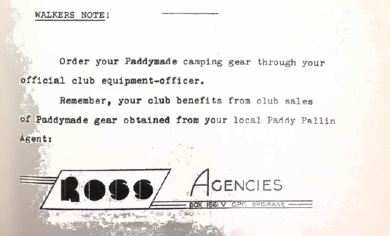

“THROUGH THE LOOKING GLASS”
R. O’Donnell
The chronicler bent over the pages of the huge book before him and commenced to read to the members of the court assembled before him:
‘Thus is it written in the History of Mount Barney. At the time known as Eater and in the middle of the night, five people came to the great mountain. They were Bushwalkers of the University and mighty indeed in their powerfulness. Two youths and three maidens there were, and it was noticeable that they were slightly unsteady in their walking, for they had just come from a great celebration. They did approach the mountain through the Lower Portals, but the cunning mountain played a trick on them and moved a part of itself so that hey did walk around in a circle; and they were mightily surprise to find that they had been in such circumnavigation. And they alighted themselves, and walked up the creek known as Barney until they came upon a large swimming hole. And they ate heartily and went to the stream to bathe, for such was their wont. ‘
“They are people of strange habits” said the scribe.
‘And they lifted great objects which they placed on their backs and departed, and went up to the top of the Barney waterfalls. And the skinny one, renowned for his agility, did go up a rock slab, and did cry out that he was stuck and in much vexation. And the other marvelled that he would provide a mighty spectacle in falling over the waterfall. But in compassion they assisted him and they went their way up the mountain. And they sweated much and talked little in the labour of going up. And they climbed until the shadows were long about them and until they found a flat spot. There they camped, as was their wont.’
‘And one made a great fire and photographed it and was called a fool, for it is assuredly believed with great faith in these regions that the bigger the fire, the bigger the fool that lighteth it.’
“A saying of great truth” said the soothsayer.
‘And the photographer one wandered away and photographed in the night with much skill. But the mountain did trick him. for when it heard the click sound of the photographer one, it moved itself with much speed so that all the photographs blurred over. And upon the morning of the second day they again did rise, and eat, and depart int their fashion. And they clambered upwards upon the rocks of the ridge that leads upwards to the Leaning Peak. And it was noted that the one that was called the Grape (for she had a mighty addiction to it) did lag behind, and being behind, became further behind until the others did stop and wait for her, for they did have need of her presence for she alone could frighten the Monster of the Barney Mountain, by means of her terrible roar.’
“Indeed, I have heard her in my sleep” confessed the Queen.
‘And again, the mountain played a trick upon them and they were confused. For such was their prowess in these matters of the walking and climbing that only a trick could confuse then. And it happened that they had walked for an hour and, as the mathematically minded people would say, the line integral of their path was zero, for they had progressed none. And, lo! The skinny one did again become stuck and another did come to the rescue and stood beneath the one that was gibbering in his difficulties, whereupon this latter one did cruelly jump on the other one’s shoulders and did bound away laughing loudly in his relief of being unstuck. And the mistreated one did climb slowly up with a thin white line and did lower the line and the others came singly up on the line until they were all up.’
“It could not be otherwise, for thus I predicted it” said the oracle.
‘And they climbed to the top of the peak known as Leaning. And the shadows were of medium distance, and it was very dry for there was little water. But they did not slow down for they had much to do; and in what they did, they were not deterred by the sight of old frayed ropes that had belonged to the ones that had failed before. And they lowered the white line down over the mighty precipice and one did go over the precipice and down the line until he came to the bottom. Then the great objects came down with much skill, grace, dexterity and prowess, as was their wont.’
‘And all being down they coiled the line and left. Now it happened that they were very dry in the mouth and throat for they had had little water. And, lo! They came upon a small pool of water in the rock. And they rushed upon the pool like furies, throwing themselves down onto the rock beside the pool and thrusting their heads into the pool. Great and loud was the noise of the slurping and gulping that arose out of the heads in the pool and fille the air. And they consumed all the water until it was gone and the little creatures that did live in the pool like furies, throwing themselves down onto the rock beside the pool and thrusting their heads into the pool. Great and loud was the noise of the slurping and gulping that arose out of the heads in the pool and filled the air. And they consumed all the water until it was gone and the little creatures that did live in the pool and who had not been swallowed up were dumb in their astonishment at this event and they were left gasping.’
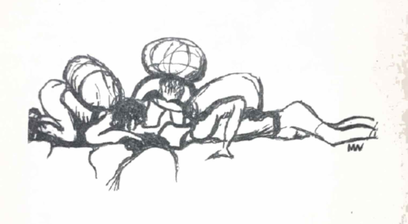
“A most peculiar habit” cried the chronicler.
‘Now the shadow had lengthened and had fused into the oneness of the night but still they walked, as was their wont. And by the aid of small white lights they stumbled and fell into the saddle that lies between the peak that is to the North and the one that is to the East. And there they stopped for it was known to be a good camp site. And they looked for wood and water and, lo! It was difficult to find but they found some for they were skilled in these matters. And the next day they did rise before the great red and yellow orb had appeared and they went and sat upon a rock facing the east and waited for the appearance of this great marvel. And when it was done they celebrated the time of the Easter Bunny which had come in the night, and they marvelled upon this, for it was not known to them that bunnies could lay eggs. But so it is written and strange are the things that happen on the Mountain Barney.’
“A tale of high adventure” said the King.
‘And they climbed up onto the peak to the East and drank plenteously of the water they carried. And they descended to the hut which had been built by those of past generations and which had been of much contention and argument amongst their fellows. And that night they did cook and sleep in the hut. And the smoke that would not go through the strange chimney device did not fill the hut with itself and induced much coughing and spluttering so that they went outside and breathed, as was their wont.’
‘And coming inside again they banged their heads against the great metal chimney device and a hollow sound was heard and it is deductible from this event and their previous conduct that their heads were merely for ornament and for no practical purpose other than for the eating and drinking.’
“Truly a peculiar race that they would put up with this chimney!” exclaimed the soothsayer.
‘But mightily did they feast that night for such was the skill of the maidens that they prepared a sumptuous meal and they dined heartily, as was their wont. And they laid themselves down on the bunks of the hut but they could not sleep. And it was not known whether it was the boards of the meal that was the cause of this.’
‘And it was overheard that they were much in the way of saying: “Just ask me if I can climb a rock, just ask me”; or gain: “Just ask me if I can find water, just ask me” and many other similar pronouncements. And it was heard at one of the times when they were wont to eat, that when one took something of the other one’s without enquiring as to the allowability of the taking, the offended one would say: “Hey, who said you could have my jam?” whereupon the other one replied with much conviction: “Just ask me if I can take your jam, just ask me”. And the offended one did ask in the prescribed form and the taker of the jam answered with much gusto: “You bet I can!”. And the offended one fell silent as in a great quandary. And this is all that is recorded of the conversation of these five, for you can see for yourself that it was much nonsense and not worth the recording thereof.’
“Quite so, quite so” said the scribe.
‘When the last day of the Easter had come, they departed down the Gorge, alternatively walking, eating and swimming as was their wont, until they had left the mountain. And they were triumphant in their conquest of her. But the mountain had not done with them, for she still had two tricks to play. For when they returned to the creek at which they had first camped, lo! Nearly all the water had gone. And though they were thirsty they could drink but little. And also when they returned to their car and were preparing to leave, they found that one of the tyres was different to the other three for it was flat. And with much difficulty they fixed the tyre and left. And just as they left the rain began to fall.’
“Thus is it written, sealed and signed in the History of Mount Barney” ended the chronicler.

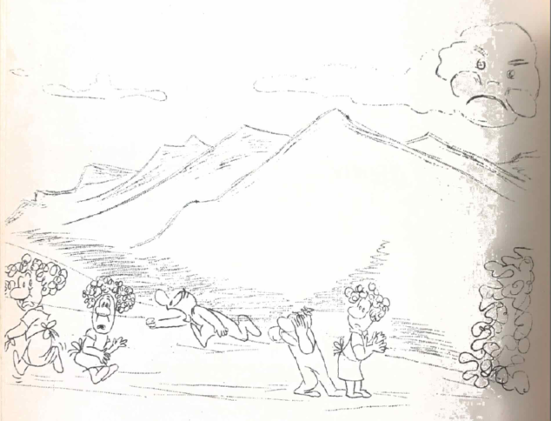

IT CAN’T HAPPEN HERE?
Eddie Hegerl
When I was eight years old, I was a great philosopher, scientist, skin diver, and bushwalker, and would have freely admitted it to anyone showing even a little curiosity. The years have not treated me kindly. In fact, I have retrogressed into being a climber who can be depended upon to fall spectacularly form even the most modest bump in the landscape.
My philosophy has become increasingly simple. An egg cooked over a tiny Townsend fire on Mt Barney is nice. Girls are a little nicer. But about one thing I can get all wild-eyed and militant – the abuse and misuse of the bush and the sea, and the animals they contain. More simply stated – for simplicity suits me – I’m a fanatic conversationist.
Possibly, being a Yank from New York City – hell, to be more specific, the good old, old slums of Brooklyn – had a lot to do with it. I spent my early years surrounded by cement, thus appreciating more intensely things living and things green. Then my parents moved me to Florida, and I was soon out in the bush and under the sea. As the years passed, I saw the forests bull-dozed to make way for the garish cancers of the American suburbs – housing developments, and the creatures in the sea “shot out” by hordes of spear-wielding skin divers, or dredged up and sold as curiosities to the fat, sun-burned tourists on the beaches of south Florida. Motorists took every opportunity to chuck rubbish out of car windows, and many hauled old chairs and beds into the country and left them, as if what was a blemish in the bedroom would look better in the bush.
Maybe some will call this a “sign of progress” signifying the “advance of Wester civilization”, but I am inclined to more cynically regard it as a bit of the old Midas touch, a specialty of the “civilized” Homo Sapiens.
Perhaps you can say that it can’t happen here in Australia,* because the country is so big and there are, for example, countless thousands of kangaroos. In America, there were countless thousands of buffalo, until it became fashionable to shoot a few for Sunday sport. They and many other animals would probably be extinct today, if a few militant conservationists had not all but threatened to storm Washington if national parks were not established and animals protected. Perhaps you think there are plenty of fish in the sea, but if you dive you have probably noticed that there are a lot fewer these days on the reefs within 150 miles of Australia’s major cities than there were a year or two ago. Diving is not a “big deal” sport – the underwater butcher has been popularized into a hero. A noted Australian diver called last summer “the season in which there were about two skindivers chasing every one fish”.
Underwater national parks are as necessary as those on land. Beautiful areas on land and under the sea, and the animals they contain, must be preserved and protected to prevent their eradication or future generations will be left an ugly, barren planet.
National parks, even on land, admittedly present many problems. They are for all the people, but if all the people rush into them, the flora and fauna will inevitably suffer.

* Not to be taken as an insult to the present Liberal administration
If the park is large enough, this problem can easily be solved. Paved roads can take the tourist-types to attractive picnic sights at the edge of the park. Tracks can go further into the park, graded for perhaps the first few miles, and with huts spaced at reasonable intervals. Finally, a large section of the park should remain completely untouched for those who prefer Nature natural.
It would hardly be good conservation, if after reading my moderately demented ravings, you rushed outside and used a green eucalyptus branch to bludgeon to death the first hunter or spearfisherman you encountered, but I do hope that my bushie buddies will at least become a little more militant about preserving our* bush, our caves, our reefs and wrecks, and all our wildlife.

* I am half way to citizenship – another 21 months. Perhaps at least my feet should be considered Australian.

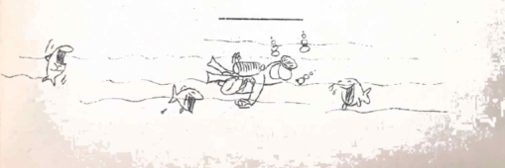

HOMELAND
Ted Tesch
In the first instance, the title of this essay was “Huts for Bushwalkers” and under this heading it was intended that the particular problem of huts be examined in parallel with a similar problem of much greater significance. However, while this method might lead to a fuller understanding of the hut question, there were too many factors involved to allow a brief treatment of that question so placed. Consequently, the title “Homeland” has been adopted, and the parallels mentioned earlier may be developed by the reader, should this be desired.
Each and all of us, whether we realize it or not, are involved in a unique environmental problem of truly vast proportions, for the Homeland of modern man has become the stage on which the enormous forces of nature and modern manufacture play out their possibilities. We cannot, by any means, be sure that “manufacture”, as we know the process, can provide us with an external environ adequate to our needs as human beings. In fact, when this process is examined from a viewpoint which takes account of what would be considered normal manufacture in a traditional sense it is, evidently, seriously astray, and amounts, in practice, to an innocent, but wanton, desecration of our homeland.
It is unpopular, these days, to regard nature as Beautiful, and those who do are apt to be accused of being sentimental – even unrealistic – or impractical, but this accusation is symptomatic of a widespread disorientation of the mentality of modern man, rather than some brave, new outlook. In reality, nature is Beautiful; the condition out of which Beauty develops and the significance of this state do not cease to be relevant to human well-being and welfare, simply because of a “progress” that chooses to ignore them.
In a general way, formal Beauty – for this is the mode of Beauty in question – is the state of perfection in form which, in itself, is for the contemplative at least, symbolic in an iconographical sense. It has a sacred significance at the same time that it is a material occurrence in a secondary sense. However, it would be an error to assume that this same Beauty of form with its “iconographic” or intelligible utility, is of no “practical” utility, such as moderns seem to assume. In fact, a manufacturing process which does not include formal Beauty in the ends to which it is devoted can only lead to a progressive deformation of humanity’s external environ, so that man alienates himself form what he has made – hardly a practical development.
In many respects, it seems that this alienation is already present in our experiences, and under this condition, it is towards nature as we see her, that we must turn, to realize that formal Beauty is a condition compatible with, and even the norm of, environmental form. Nature, and nature alone, offers us this experience, and if its significance and the “technical” conditions out of which formal Beauty develops are not retranslated and applied to modern manufacture, man as a whole will rob himself of a homeland adequate to his needs.
Is it too much to claim that, when manufacture becomes desecration, man must become the protective curator of nature, as though she were some vast museum not “respectably” relevant to the serious concerns of life? Is it irresponsible manufacture that lends to the conservation endeavours their protective aspect?¹ Can we afford, indefinitely, to ignore the relevance of formal Beauty to the adequacy of our homeland as an environment fulfilling human needs?
These are matters that we might all do well to consider according to our capacity, for our interest (as bushwalkers) in nature offers us an intense experience of her formal Beauty and it might not be too much to expect that we can place a real value on this quality, and even come to expect and require its presence in the manufactured environ. If it was more generally recognized that the natural environ is, in reality the only source of formal beauty in our homeland, there would be more than sentimental reasons for opalceing a value on this environ, just as the poverty of our manufacture in this respect might thereby become apparent.
Perhaps enough has been said about the environmental problem referred to earlier, to indicate that it is anything but a minor one of little importance, and it may be both of interest and value to continue a little further with an examination of it.
An understanding of the traditional idea of manufacture makes it clear that this formative process requires that humanity exercise, not only science, but art as well. Not only are we bound to take account of what is mechanically true of the nature of the materials and energies of our external environment, but also what is truly significant in the forms that allow an arrangement of these materials and energies. While “art without science is nothing” science without art offers us no truths except “mechanical” ones. In a very simple, but not wholly inaccurate way, this disequilibrium between science, and art in contributing to manufacture as we know it, can be regarded as the operative source of the environmental problem we are facing. Briefly expressed, our technology – the first machine technology- - has suppressed almost to extinction our capacity to believe that reality itself is more than a merely mechanical procession of events. We seem to forget that this mechanistic pattern bears only a conventional correspondence to reality, and that it does not adequately retrace the total possibilities inherent in the mime of creation that is art’s responsibility to represent.
In practice, we have arrived at an “impasse” where scientific mechanics or artless mechanization – whichever you will, has altered not only the external environ of man, but his internal environ as well. In order to indulge our preoccupation with machines and their mass methods of “creation” we have “en masse” accepted a rationalization of formal Beauty into something “preferable, according to average taste”.
Lost thereby is the indispensable standard of reference, in so far as formal Beauty is virtually unknown to us in its true nature and significance. Inward criteria are all but lost and, in their absence, it may be possible that the outward evidence that nature offers may come to our aid, pathetic though a recourse to “naturalism” may be in this respect.
Finally, it should be maintained at every opportunity, in the interests of the Beauty of our homeland, that a love of nature, in one way or another, is to be found in us all, and that it is a norm for humanity. For some, it may have detracted, so as to evidence itself as a nostalgic delight in plastic flowers, while elsewhere, we find evidence of its presence at the social level, in endeavours such as conservation. Ni fact, it is by an error developing from the growing influence of what is artificial in our lives, that a love of nature has come to be regarded as a sort of sentimental devastation sway from the “serious” concerns of life.
Nature may offer us an “escape” from these “serious” concerns, but, at the same time, she provides a “retreat” where many things – elsewhere difficult to locate – can be found and sometimes, re-created. For many reasons, conserved nature is of inestimable value as a presence in our homeland.

1 – It is interesting to note that, in our own local National Parks, the signs, buildings, etc. have been deliberately given a "rustic” character. This is, in itself, a simple restraint placed on the type of manufacture considered appropriate. Any hut that bushwalkers might build is to be deprecated, if it cannot conform to this simple discipline. Very much more than this restraint is possible, and any construction associated with natural retreats will need to discard the blatant, mechanistic character that typifies construction elsewhere in our homeland. Mechanization is a means of assembly, not a formal discipline, except that it be accorded the influence appropriate to a “tool”. No aesthetic (in the contemporary sense of this word) compensations can possibly restore the equilibrium of anything which has been made by a formative process which is merely mechanical assembly. It may be of merit to make “nice” things, but this is no guarantee that such things will not be deformed.
-----
Anyone interested in traditionally orthodox expositions on the concepts of art may find the following value.
“Christian and Oriental Philosophy of Art” – A.K. Coomaraswamy.
“Spiritual Perspectives and Human Facts.” – Forthjof Shuon.
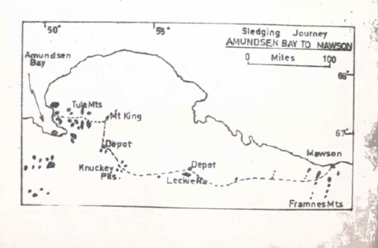

SLEDGING JOURNEY – AMUNDSEN BAY TO MAWSON, ANTARTICA
Ian McLoad
In the summer of 1958-59, three members of the 1958 party of the Australian National Antarctic Research Expedition made a 400 mile sledging journey from Amundsen Bay to Mawson. The journey was made to continue the geological and topographical surveys by earlier parties. The three men were Graham Knuckey (surveyor), Peter King (radio-operator), and myself (geologist).
The maps then existing showed the major topographic features, but only very sketchily, with little detail. Many features, but only very sketchily, with little detail. Many of the features had been plotted from aerial photographs taken many miles away, while their relative positions were correctly shown on the map, we found that some of the rock exposures had been plotted up to 20 miles from their proper position. This was no reflection on the ability of the cartographers – they had done a very good job with he material available to them. Graham’s job was to measure accurately the position of some of the rocky peaks projecting through the ice, by observations of the sun and starts (an astrofix). These peaks could then be used as a reference for plotting other nearby features. I was to do as much geology as possible, and Peter was to keep us in touch with Mawson.
For the journey, we used two dog teams – one of seven dogs driven by Graham, and one of six dogs, which I drove. Our starting point was Amudsen Bay, 350 miles west of Mawson. Two intermediate depots were established, one at McLoad Nunataks and one at Leckie Range. Aircraft were used to set up these depots, and all the dogs, sledges and gear were flown from Mawson to Amundsen Bay during the week before the start of the journey.
The last of the dos were flown in on the 27th November. Late that day, we harnessed the teams and took half the gear across the sea ice and to the top of the steep slope forming the edge of the continent. The complete loads (about 120 lb. per dog) would have been too much for the dogs to pull up at once. As the ice sheet rose 250 feet in a distance of 600 feet.
A week of warm weather had turned the snow around the tents to ice, and it took us an hour next day to dig them out. The dogs were restive after their spell of idleness; we had to break up several fights as the teams were being harnessed, and the fighting continued as we move doff over the sea ice. However, we eventually reached the top of the slope, re-packed the gear, and in brilliant, warm sunshine, with no wind, we set off up a long, rising snow corridor between two rocky ranges of the Tula Mountains. The dogs soon settled down, and pulled steadily at a man’s risk walking pace. The snow was soft, but much of it had a hard crust which would break unpredictably – sometimes as soon as we put a foot down onto it, sometimes in mid-stride, and sometimes not at all – so a steady pace was hard to maintain. The snow also concealed small crevasses, and every so often a dog would break into one, or one of us would put a foot through the bridge. We considered roping up, but inspection of some of the crevasses showed that they were all small, so we contended ourselves with keeping a firm grip of the sledge handlebars. The exertion warmed us up, and we began peeling off layers of clothing, and were soon walking hatless, gloveless and shirtless. The dogs were pulling steadily, and their tongues lolled far out. It was a relief to us all when a slight breeze came up shortly before we camped for the night.
We quickly developed a routine for camping. As the time approached, the leader of the lead team would look out for a patch of smooth, hard snow, large enough to pitch the tent. The harder, the better – the tent pegs held more firmly, the snow didn’t compact and turn to ice under our weight, it was easier to melt for water, and we didn’t bring a lot of loose snow into the tent. We soon became expert at spotting suitable snow and complained mightily if it couldn’t be found.
The first task after stopping was to span out the dogs. The spans, one for each team, were lengths of wire to which each dog was attached by a short chain, far enough from his neighbour so that they couldn’t reach each other. Each end of the span was attached to an angle-iron peg which was driven into the snow. On a couple of occasions, the dogs, leaping about excitedly as they were about to be fed, pulled out one end of the span, and then there was chaos, especially on the occasion when one end of each span came out at the same time. After that incident, we took care to bury the pegs completely although it meant a quarter of an hour of hard work recovering them next morning.
While one of us prepared the site for the tent, another began carrying equipment to it from the sledges, and the third got out the pemmican for the dogs, cutting it up if necessary. Each driver then fed his dogs and went along and gave each a pat; the dogs were mostly too interested in the food to return the display of affection. Depending on the wind strength, two or three of us then erected the tent, the gear was put inside, the radio aerial laid out, and after a last look at the dogs we would retreat to the interior of the tent.
Normally, our only drink during the day was a mug of cocoa at lunch. Liquids had to be kept in a thermos, and on he second da one of the two we had was dropped and broken. By the end of each day we were parched, so the first job in the tent was to melt snow and make a drink of lemon crystals and sugar. After a pint of this we were ready to start eating. A ration pack lasted for four days. Each of us cooked for four days at a time, so could make the most of the limited resources of the ration pack, plus the few “luxury” items (jam, honey, curry powder, dried fruit, etc.) we had allowed ourselves. The menus were simple: Breakfast was porridge with sugar and powdered milk, sledge biscuits, and coffee or cocoa. Lunch, eaten squatting out of the wind beside a sledge, was sledge biscuits and cocoa, and diner was pemmican (flavour with curry, egg powder, onion, or a strip of bacon), the ubiquitous sledge biscuits, and tea or coffee. Although we ate this for nearly two months, (except at the depots, where we lived on tinned food) we never found it monotonous, probably because of the variations, intentional or otherwise, produced by the cooks.
The radio sked with Mawson came at 11.30 pm, during, or just after the meal. We sent them our progress for the day, plans for the next day, and weather conditions, and they sent us any messages and camp news. Occasionally, we made contact with another party making a seismic traverse south of Mawson to measure ice thickness. The sked finished, the radio was put away, the cooking gear piled on top of a box, and we crawled into our sleeping bags.
The alarm was set for 9 am. The tent, which the previous night had been warmed by the primus, was now icy cold with hoar frost encrusting the lining and hanging from it in streamers. Carefully, so as not to shake the frost from the tent, the cook would fumble with he matches and get the primus going. The other two slept on, hidden in their sleeping bags. in ten minutes or so, the heat of the stove would dissipate the frost and it was safe to move. The cook would make the porridge, butter the biscuits, then wake the others. Breakfast over, we would dress, pack up, and emerge from the tent. The sledges would be packed, the dogs harnessed, and about midday we would be on the way.
The dogs, too, soon learnt the routine. In the early stages of the journey, the first man to emerge from the tent was greeted by a chorus of yelps and howls, and the sight of two spans of dogs leaping excitedly about. This quietened down after about five minutes, but every new move on our part was the signal for a fresh outburst, and these reached a climax when the dog harness was produced. As time went on, the dogs’ morning greeting was more and more restrained. The last job before harnessing the dogs was to lash the tent to one sledge; after a couple of weeks, it was only when this was done that the dogs would get to their feet, shake themselves, and wait to be harnessed.
The dogs’ behaviour while the team was being harnessed was usually a good indication of how the day would go. Normally, they would sit quietly after being harnessed, but at times, especially after a period of idleness because of bad weather, they would get up and walk around, tangling traces, and more often than not, starting fights. On such days the driver had an active hour of two until the team settled down.
As we climbed eastwards through the Tula Mountains on our second day, the temperature fell and travelling became more pleasant. The snow was harder, which made for easier walking, and we traversed long stretches of bare ice. Late that afternoon, graham decided that a small, isolated nunatak we were approaching would be suitable for an astrofix. While he and Peter made the observations, I had to look at the geology, while he took photographs and a series of theodolite angles to surrounding features. These activities became the pattern wherever we stopped for geological and survey work.
On 5th December, we turned south from the eastern end of the Tula Mountains towards our first Depot, climbing gradually but steadily, on a surface of hard-packed snow. We were now experiencing weather typical of good days on the inland ice sheet – a temperature of about 10 degrees F (it became colder as we traveled further inland and climbed harder) a 20 knot wind and a clear sky or thin cirrus cloud.
Next morning, the weather was different – a steady 40 knot wind and visibility of only a few hundred feet and getting worse. It was obviously impossible to travel, and we spent the day in our sleeping bags, or siting on them writing up notes. The weather didn’t clear until the 9th, and late the same day we reached our first depot.
Here, we spent two days doing geology and survey work and repairing sledges and gear. The pile of empty tins around the tent grew rapidly, as we demolished the stock of tinned food left there two months before. The dogs, too, lived well making short work of the seal meat we had left there for them. Perhaps, because of the unexpected feast of seal meat after they had become reconciled to pemmican, the dogs were reluctant to leave when the time came on the 12th December. We were less concerned – we knew all the food had been eaten.
We were still heading south and climbing towards the Knuckey Peaks. Their position on the map suggested that we were still a good day’s run for them, but we suddenly realized we were almost there. They were plotted 20 miles from their actual position. The weather closed in the night we arrived, and we had to wait three days before it cleared and Graham got his astrofix. The weather was a continuing problem for Graham. Even thin cirrus cloud was enough to obscure the stars, and on a couple of occasions we had to leave a locality before he had made all the observations he wanted, rather than lose any more time. Fortunately, I could do geological work as long as the weather was clear enough to get to the rocks and back, so, often, Graham’s delays were my gain.
From these peaks, we turned east towards our second depot at the Leckie Range. The next two days were the most unpleasant of the whole journey. The surface was soft, smooth snow into which we sank ankle deep at each step. Cloud was down almost to ground level (here we were more than 6,000 feet above sea level), and although there was little wind, snow squalls swept down on us every hour or so. On the second day, we began to descend slowly, and the surface improved on the third day, but the low cloud and snow persisted, and in addition we had to traverse several badly crevassed zones, which slowed our progress even more. We didn’t reach the Leckie Range until the 27th December, and spent most of that evening eating a delayed Christmas dinner. We had had a special radio sked with Mawson on Christmas Day – in fact, Mawson, Davis, the seismic party and we, had all talked with each other. All the other parties described their Christmas menus in some detail, before asking sympathetically how our pemmican tasted.
At the Leckie Range, too, we had to wait a couple of days for the weather to clear for the survey work. When Graham and I climbed to the summit of the Range, we found that it was 2,000 feet above the ice, far higher than we expected. However, the view was well worth the effort. Without reference, features such as trees, scale is very hard to judge in the Antarctic, even with experience. The usual method is to estimate the distance or height, double it, and then add a bit for luck.
The third stage of the journey, from the Leckie Range to Mawson, was the longest, and we set off with loads of more than 150 lb. per dog. Even so, the teams kept up a smart pace for a couple of hours; this pace, and a resulting tendency to cut corners, was particularly disconcerting while we crossed a couple of badly crevassed zones, but we managed to negotiate them without mishap.
Another four days saw us at Farm Peak, late on the 4th January. Cloud came up next morning while Graham was making his observations, but he managed to get enough for his purpose. The weather got worse during the day, and next morning we awoke to find the visibility was only a few yards. During the next two days, about two feet of snow was deposited on the surface. The tent was half buried, the sledges almost completely covered, and the dog spans had to be raised at intervals to keep the dogs above the surface. Every time we went outside ,we stumbled around in knee-deep snow. These conditions lasted, with gradual improvement, for five days. It then took us half a day to dig everything out, but we finally got away, the dogs floundering on their bellies through the soft snow, and the men holding desperately to the sledges to keep up. Fortunately, the conditions improved rapidly, but we didn’t get out of the soft snow for another two days.
This was our last bad weather. On the 18th January we could see some of the peaks of the Frames Mountains, south of Mawson, and on the 19th we topped a rise to find a panorama of all the ranges in front of us. The next day we met the tracks of the seismic party, which had reached Mawson three days earlier. The dogs must have recognized the tracks, because they set off along them at high speed. The marker flags left by the seismic party also attracted them, and every so often, some of the team would try to pass to the left of the pole, while the others tried to pass to the right. The dogs greatly enjoyed the resulting confusion.
We camped for the lats time on 20th January, among the ranges about 15 miles south of Mawson. Progress next day was slow. Most of the travelling was over slippery, bare ice, and the dogs had trouble keeping their feet; so, did we. Fortunately, the route was now downhill all the way. At last, we came to the head of the long, shallow valley leading down towards Mawson, 2 miles away. There seemed to be people everywhere. It was a pleasant, sunny evening, and almost the whole camp had come out in groups of two and three to meet us. The next half-hour was a confusion of greetings, photographs and questions, but we finally got the dogs tied up at the dog lines and fed.
We had left Amundsen Bay 54 days ago; on a third of those days we had not travelled, either because of the weather, or because we were working. We had traversed 400 miles of little-known country, considerably extended knowledge of the topography and geology, and brought all the dogs back in good condition. We felt it was a fitting climax to our year at Mawson.

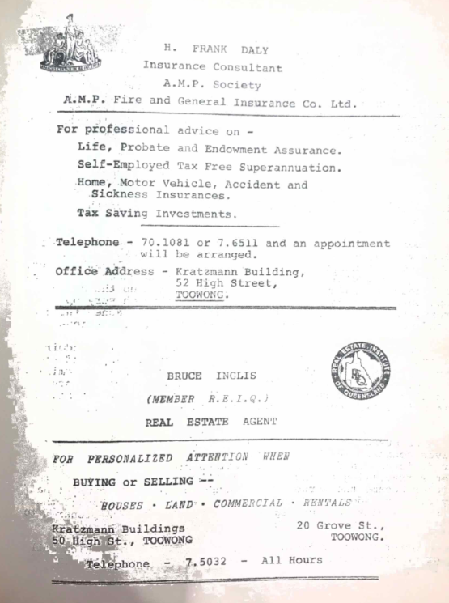

TWEED RANGES “A SCUNGY TRIP”
Ken Taylor
Rain, rain, and more rain. At 7.25, Kidney Lawn looked cold, wet, and empty. Five minutes later, eighteen optimists were gaily discussing the prospects of a drought in the Tweed Ranges. Everybody piled into one view, one Mini, and the ‘bus. John Tillack drove that ‘bus like Radish on a mud track! Travelling about 120 miles in the rain (two miles all told, going sideways) we pulled up in somebody’s scrap-metal heap. After debating the issue, we decided that it wouldn’t make such interesting walking, so, talking the ‘bus with us, (why didn’t we leave it there?) we rattled on a few more miles.
At two am, we pulled up, settled in, and spent the night under the stars. Dark and mysterious were the peaks around! Somehow, down in the valley on a moonless night, I get filled with a longing for light, just to see the shapes of those dark, challenging peaks on the horizon.
Morning dawned fair, and after a look at the half-empty creek, we all crammed into the ‘bus with our packs and were away. Amid warnings of “You’d better be at the Pinnacle before to-night, or you’ll never make it”, nine of us vacated the ‘bus and headed for Paddy’s Mountain. We meandered up the steep slope onto the ridge, and up a razorback, through very open slope onto the ridge, and up a razorback, through very open forest, to the top of Paddy’s. by the time we reached the top, we had heard all about commem. from our college companions.
On reaching the top, Ken Grimes – our leader – admired the extensive view to the west of Barney and Lindesay, and the mountains further south. Meanwhile, eight others were admiring the menu for lunch. Ten minutes later, Ken announced lunch. Then it started to rain. Out came the protective covering. At this point, two members decided the Local Pinnacle might be better, so back they went.
We pushed on, soon losing the open forest, getting ourselves confused in the thick scrub. Often, we were split in our decisions on directions, sometimes breaking up into two groups travelling at right angles. The more we pushed on, the thicker became the scrub. Time caught up on us, and about halfway between Paddy’s and the Pinnacle, we camped. What of the warning? Water was our big problem, and so we were prepared to catch some in our tents. No rain!
After a fairly dry breakfast, we attacked the thick wall of green with machetes, and pressed on. Thirst got us, the jungle got us, thirst got us, the scunge got us. Progress was slow. Turns at leading were not relished. Our Indonesian Guerilla, adorned in an outlandish rigout, wriggled in and out of the maze so that it was practically impossible to keep up with him. Keith, at this stage, lost half his raincoat and ran around in a waistcoat.
We sat down to a dry lunch just as the rain started. Then we pushed and shoved and moaned our way on till we hit the eastern ridge where the other party had had lunch. Dropping our packs, we followed their tracks, being led by sharp female eyes most of the way to the pinnacle. On the way, we saw a prune tin which had collected rust, rainwater, leaves and – but it sure looked good.
A loud babble of noise announced we had reached the other party at the Pinnacle. From the pinnacle there is a commanding view of the tweed Basin, which Warning as it centre. It reminded me of an ancient Roman Arena with Warning as a prize gladiator. The splendour of God’s creation made two days of intolerable walking suddenly seem insignificant. We headed back to the packs, but in the darkness couldn’t find them. We stumbled across the prune tin which, because of the swollen nature of our tongues, was carefully carried on. Finding our packs, Paul carefully strained the tin, Eric lost his over the non-burning type of wood we had, and the rest set up the tents. They managed to make some tea (without tea leaves) but then the fire died out. With no water, no fire, no patience, no warmth, nor any cooking, curses flowed free until a Tweed Ranger’s Delight was invented (what was the recipe?).
That night, it rained and poured and flooded – no water problems.
Early (?), the next morning we headed south, following the other party’s highway through medium thick scrub along the edge, for a mile and a half. We appreciate dour highway when we turned east on the ridge heading to the local Pinnacle. Strange, stunted, broad-leafed, and very thick vegetation it was.
About 2 pm, we burst out into sunshine and open forest, and what a change! Our morale was lifted greatly as we ambled down the ridge to the Local Pinnacle. Sitting on the rock, I realized how small we really are in this world, and how glorious is our countryside.
Before heading down to the ‘bus, we had corker of a fizzy drink out of a mug that was almost a wash basin. Warwick needed wipers for his glasses. Then, with Eric showing us how to ski, we set off down the very steep descent. Who needs snow to slide! Down at the bottom with a bang, we found the ‘bus just as it started to rain. We drove back to the sawmill, arrived at four-thirty. About eight o’clock the others got down, and we were back in Brisbane by one am.
I hereby wish to thank the owners of the sawmill for their hospitality and generosity, and may we, as bushwalkers, never forget this kindness from them, and others like them.
The Tweed Pinnacle is best attacked from the eastern side. A steep climb from the Limpinwood Valley up the side of the Pinnacle is obtained from the end of the road. You can see the correct route from the bottom. A longer route through the same thick scrub, though only a two day trip, may be taken from O’Reilly’s or Binna Burra, heading south along the main range from Bilthongabel. This is a very interesting, though not too strenuous trip if you don’t get lost. Keeping on the eastern lip is the best idea.
The whole area there can only be really described by the eye, and the trips done in that area will certainly reward a bushwalker with magnificent views, slides and memories.

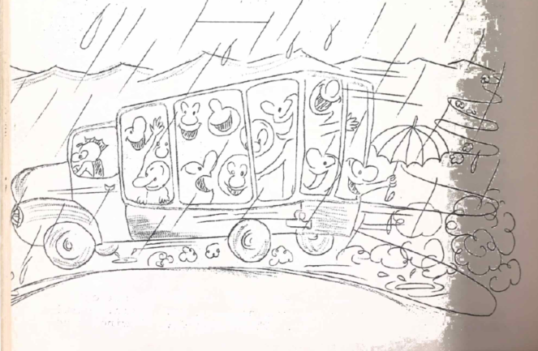

A BUSHWALKER’S PARADISE – OR “PLEASE GO SOUTH”
R. Leavy
The second title is intended to directly oppose the title of Doug Clogue’s 1961 article, “Why go south?”.
I have noticed that, in recent years, there has been very little tendency for up and coming young members to follow in the footsteps of older members and go bushwalking in “Tassy”. Not wishing to diagnose the cause, but instead, to effect a remedy, this article hopes to lure present and future members of U.Q.B.W.C. (not tourists*) into the “wilds” of Tasmania.
There is nothing like knowing where it is you are supposed to go (contrary to the normal bushwalker’s policy), so I will elucidate: the Cradle Mt-Lake St Clair National Park is reached from Devonport (60 miles) or from Hobart (100 miles). Since tourist ‘buses pass daily within four miles of the southern end of the Park, (a crossroads called Derwent Bridge) since better views are obtained walking from south to north, and since food is bought more readily in Hobart than in Devonport, I recommend that the Park be approached from the southern end (whew!). There is also the added advantage that the park Ranger at Cynthia Bay (the southernmost end of the Park) will take bushwalkers up Lake St Clair to Narcissus Hut for 2 dollars a head, but, I must add, only in the teeth chattering hours of the morning can you make the trip.
If you are like most university students, the 2 dollars fee will be too staggering, and you may prefer to walk to Narcissus Hut. If you do, take the route via Lake Petraceh and Mt Byron, rather than the lake route; good views of Frenchman’s Cap are seen from this track.
From Narcissus Hut, the Ducane Rane can be reached. This is the best part of the Park, and should not be missed. To climb to the Labyrinth, where camp can be made, continue past the Pine Valley Hut, following the creek route. The range can then be climbed at the depression in the skyline. Once on the Labyrinth, all the peaks of the range are put within easy access. Geryon, Acropolis, The Guardians and Walled Mt provide excellent scrambling. The range can be left off Falling Mountain, or the saddle above Kia-Ora Falls. If there is time enough to see the set of Falls on the Mersey River, then the former route should be taken.
I cannot over-emphasize the fact that most of the time available should be spent on the Ducane Range, since, after this section of the Park, the attractions – other than the magnificent alpine scenery in general – are widely spread out.
Mount Ossa, of course, is one of the major attractions of the Park, being the highest peak in Tasmania. If you are energetic enough to carry packs up the side of Mt Doris, you can camp on the most beautiful campsite you are ever likely to see. It is one of those sites that you would expect only the mind could conjure up. There is a short bush lawn with water at arm’s length from the tent, and in the backdrop, Hyperion, Massif, Falling, and Cathedral Mountains, forming an amphitheater that would match any view in Australia. Any description of the summit of Ossa would be completely inadequate, since John Siemon has done this in his article.
From Pelion Gap onwards, Barn Bluff and Cradle Mountain can be climbed, and Lake Will and Dove Lake visited in less than four days.

* Other than bona fide members of “true” bushwalking clubs.
From Cradle Mt. it is usually easy to get a lift to Devonport. There are normally plenty of “tourists” and Geology Survey vehicles going in and out.
Some general notes on the Park:
A map covering the area is published by the Lands Survey Department.
The suggested trip can be undertaken in 10 or 12 days, but the more time spent in the Park, the better. Boots – not sandshoes – should be worn. Sandshoes cannot support the feet on the swampy parts of the track. It can snow even in February (it did when we were there); so, go well equipped with anoraka, jumpers gloves, etc. All of Tasmania’s snakes are poisonous. Tell the Ranger where you are going, expected time of arrival at the other end of the Park, etc. Most of all, when on the Ducane Range and in pine Valley, keep well away from any “Nothofagus gunii”; perhaps the word “gunii” is the origin of our word “grunger” which is the worst type of “scunge” possible?
I can only say you’ll recognize the “gunii-gunger” when you see it.*
A three week long trip cost only 50 pounds a head, including everything. Some people have wondered why I have not been so keen on bushwalking in Queensland since going to Tasmania, so I warn any walkers who take my advice to go to Tasmania that they may never lose a strange disease called “Tassy-bug” hat they will pick up.
Any takers?
* Sandy and I commented on how funny a movie film of our escapade in the “Gungerous-Goonii” would look at a club meeting. Sandy hastily added, “As long as it was a silent film”.
BARNEY TOURIST BROCHURE
Does the road wind up-hill all the way?
Yes, to the very end.
Will the day’s journey take the whole long day?
From morn to night, my friend.
But is there for the night a resting-place
A roof for when the slow dark hours begin.
May not the darkness hide it from my face?
You cannot miss that inn.
Shall I meet other wayfarers at night?
Those who have gone before.
Then must I knock, or call when just in sight?
They will not keep you standing at that door.
Shall I find comfort, travel-sore and weak?
Of labour you shall find the sum.
Will there be beds for me and all who seek?
Yea, beds for all who come.
ROCK CLIMBING?
John Milne
“Crikey! It’s high. I get dizzy just looking at it. Don’t feel like going up there.”
“Come on, you’ve got to go.”
“Yeah! I’ve promised myself. What have I let myself in for!”
“Come on. The girls are going.”
“Strike me! Now I’ve got to go. Righto – you lead up the first pitch.”
Sundry dregs of U.Q.B.W.C. step up to the first pitch. It’s not too steep, and not too exposed either. Nice, large, firm holds. Nice texture on this stuff – not too smooth.
“Is this the chimney, lay back, and squirm hole? Dark, isn’t it? Where’s the next hold?”
“Here.”
“Where?”
“Here.”
“That? ‘Struth! Not much there. There’s a long reach here, too. Hey! Look at that pitch! No way I the world I’m going up there! Well, I’ll go above this obstruction, anyway.” (Grumbles to self).
“Come on. It’s a big staircase – safe as houses. Houses do fall down, though.”
“Cheerful wretch. O.K. Let’s go.”
Sundry dregs of U.Q.B.W.C. start off on the second pitch. It’s steeper, and more exposed. Higher, too.
“This isn’t too bad. We’re nearly there.”
“Here’s the extra exposed bit.”
“Look where you’re going, man. Up.”
Sundry dregs of U.Q.B.W.C. wiggle up the last bit. Now, there’s the last few steps to the top.
“Mind the red light.”
“Nice view of Brisbane, isn’t it? Where’s the jellybeans?”

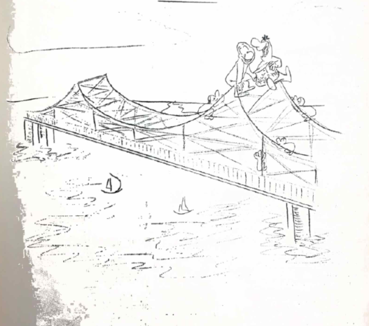

A NIGHT ON BATTLESHIP SPUR
Phillip Leask
The ridge was rough, the night was drawing nigh
As six bushwalkers climbed down Battleship;
Down fearful sandstone cliffs all looming high,
And sudden death if you should lose your grip.
The sun went down, and darkness caught us there,
Half-way down that rotten little ridge,
With cliffs on three sides – gloomy, steep and bare -
Like standing on the top of Story Bridge.
At least we had a campsite – five feet square -
And one flat spot to build a tiny fire.
There was no room to lie down anywhere,
Nor even for the ladies to “retire”!
That problem made them very quiet and sad,
But our solution really was quite good:
We turned our backs and sang “Lloyd Gorge” like mad
While they went off “collecting firewood”!
That brings me to our singing – well, our singing!
We proved that night that bushwalkers can sing!
And legend says the gorges are still ringing,
And the bunyups in their sleep cry out “King Ming!”
At one o’clock we are some peanut paste
With tasty biscuit crumbs and one old prune.
We gulped this feast with quite dramatic haste
To celebrate the rising of the moon.
By three o’clock we felt just half alive,
Our stomachs still were not exactly full.
But then we managed, almost, to revive
With a rousing singing of “The Little White Bull”.
At six o’clock the sky grew faintly pink,
Then came the dawn we thought would never come;
Then a mad hour’s rush to lovely food and drink,
While signing triumphantly “We have overcome!”
One day some poor bushwalker passing by
Will see the pile of coals we left to die;
Will see them there and vaguely wonder why
We stopped at such a place so bare and dry.
He will not know the fun and games we had,
Our little group around that tiny fire;
Or whether we went just a little mad,
Or why it is that we are called “The Choir”!

THURDAY NIGHT AND FRIDAY MORNING
Two cars, 40 people. John M. Down with Scurvy,
John T. still drunk, Barry fighting epidemic –
no ‘bus –
TELEPHONE –
Two cars, 41 people. Heard that Dennis said Anne
might come. How check up?
Ah! Rod has ‘phone No.
RING ROD –
List wet in washing machine. Sorry, mate.
Any other cars possible?
RING IAN –
Wedding on Saturday.
TELEPHONE –
One car, 40 people. Diff. trouble. Sorry, mate.
TELEPHONE –
Possible offer of car. (Careful now, lead him on!).
Rumour of 6 other people coming. Confirm 5 pm Friday.
TELEPHONE –
TELEPHONE –
TELEPHONE –
AH! WHAT THE HECK!
THEY’LL SORT IT OUT AT THE KIDNEY LAWN.

COLD CLIMATE RESEARCH IN CLOTHING AND SURVIVAL
I. Crellin
Earlier this year, Ken Grimes – that unshaven, lean, hungry-looking Kingsman (who, incidentally, is always complaining of the cold around the Uni.) – was attempting to induce me to join a party to go to Red Rock Gorge near Stanthorpe, in the dead of winter, and it was then that I decided that the problem of winter dress was one to be thoroughly investigated, if I was to be warm at such end-of-the-world places. The following report is derived (cheated, borrowed and scunged) mainly from U.S. Army Material – which is of high standard, due to the Strategic importance of the Arctic and Sub-arctic regions of Canada and Northern Russia. The Dr. Siple and Dr Bazzet “layer” system of clothing needs is once such principle upon which most of the following is built.
A basic postulation of this system is that a lot of loose layered, lightweight garments are equivalent in insulative value to a smaller number of heavier, more cumbersome garments.
For military purposes, the world is divided into layer zones, depending on the climate. Most of Australia lies in the 2 layer zone, with a winter temperature of 30-60 degrees, and precipitation falling as rain. Certain areas of Eastern Highlands of Australia – such as Victorian Alps and Cooma Kosciusko area of N.S.W. – (sometimes the Monaro Tablelands, New England, and Stanthorpe areas) are included in the 3 layer zone, which includes much of Northern U.S.A. and the Rockies, where winter temperatures are from 14-40 degrees, and where precipitation may fall as snow. The 4 layer zone includes some conversation of a suit of clothing (not a “fashion” suit by any means, but one suitable for Bushwalkers, outdoor workers and Military bodies) from 2 layer to 4 layer is a virtue, as is the copy allowance for overheating, etc., which is discussed later in the report.
Insulation has one great enemy – Moisture! Rain fills dead air spaces in isolation and renders it ineffective. Rubber ponchos and boots keep rain out, but sweat in. sweat from the inside destroys insulation value of cloth just as effectively as rain would. The U.S. Army has developed a chemical water-repellant called “Quarpel” which enables cloth to keep rain out, and yet allows sweat vapours to pass through unhindered. It was the unusual virtue of being able to stand up to repeated launderings. A new approach to this problem is to sandwich the insulation between waterproof layers which cannot be wet from either inside or outside. Experiments have shown that, although many of us profess to feel colder in damp weather, there is no backing for this, unless we are actually wet.
Our feet are often neglected, as shoes have little insulative value and at moderate temperatures feet may not become uncomfortable enough to warn one before one receives an itchy, burning case of trench-foot or chilblains. In Korea, in 1952, a new type of boot of Poly Insulator encased in rubber virtually eliminated such injury to feet by providing sufficient insulation. It is noted that experienced Alpine climbers do not bivouac in their boots, but in woolly, waterproof bivouac slippers for greater insulation when the feet are not producing heat through movement.
Wind can make one feel much colder that it actually is. In a 2 or 3 m.p.h. wind the skin cools at over twice the rate which it does if the wind less than 1 m.p.h. Thus, a thin windbreaker can keep one as warm as the thickest layer of insulation in a light wind. An inadequately clad man can stand still air at 23 degrees, and in bright sunlight may even feel pleasant. If a wind of 1 m.p.h. is blowing, it feels cold; if 4 m.p.h. very cold, and if a 9 m.p.h. wind blows, he feels bitterly cold. The “wind chill” effect is greatest when winds of low velocity blow onto someone wearing little or no clothing, as it tends to break up the stagnant layer of insulating air over the skin of clothing.
The head is the biggest heat leak of the body. The body will cut blood supply to the skin of the hands and limbs to conserve heat loss, but it will never reduce blood flow to the head, no matter how cold the head may be.
Layer type gear has the advantage of being able to be peeled off bit by bit, but research has shown that conventional clothing has a control measure inadvertently built into it, in that the bellows action which occurs when the weather is walking forces the hot, moist air from inside, out through the neck and forces the hot, moist air from inside, out through the neck and arm openings. This can be further improved by adding waist openings which allow better circulation of air. The wearing of a “Norwegian String Vest” – a vest knitted of coarse yarn with large holes in it to trap large layers of dead air, or to provide for a chimney-like draught of air from the waist opening to the neck opening – is to the advantage of the wearer. It is, therefore, wise to pay attention to the openings around the neck, hands and armholes, to conserve maximum amount of heat. Cold hands are a problem which has resisted science. If over 4 inch of insulation is put around the fingers, they become useless for clutching or manipulating. One new approach is to cut a glove so that it is in its position of maximum insulation when the hand is bent, and the fingers curled. Most gloves are cut to fit the hand when flat, and so, stretch the cloth when the hand is clenched, and destroy dead air and insulation. Since the main blood vessels of the hand lie on the back of the hand, a glove with good warmth and reasonable grasping power and sensitivity of touch can be achieved by placing large amounts of insulation across the back of the hand where the blood vessels lie, and to leave the inner grasping surface of the hand only lightly covered. The ideal solution for our male bushwalkers, however, is to find an innocent little fresherette who needs to be led by the hand.
For very cold temperatures down to -60 degrees F, research is carried on in the Arctic aeromedical laboratories in Alaska. these stand 13,800 ft on the summit of Mt Wrangall where there is constant cold, high altitude, reduced oxygen and prolonged darkness, all the ingredients for a successful bushwalker/ apart from physiological studies into human characteristics and endurance in the cold, clothing, food, oils, munition and weapons are tested here. Standard tyres freeze and fracture in the cold, and lubricating oil becomes semi-solid and refuses to lubricate. Tests have shown that soldiers lose 2% of their combat efficiency for every degree which the temperature falls below Zero. This means that the bushwalker wandering around in the 25 degrees F at Stanthorpe may be 150% efficient – impossible – mustn’t be the same above Zero. Studies show that the traditional cross-country travel on skis is not as good as snowshoes, in view of the fact the average fellow can become a proficient cross-country snowshoer in only 3 hours, compared with several months if skis are used. Research is being carried on to produce a tent to be erected in the Arctic night, in a blizzard, without battling a maze of ropes, pegs, poles and mauls, and a new tent suspended from external plastic bows has been produced. It only needs guys in a very strong wind, and can be erected in 5 min. in the worst of conditions.
NOTE: Researchers got an extra hour and a half of sleep before awakened by cold, if they had a 500 cal. Meal before retiring for the night. This is because the body has a higher metabolic rate after eating. The test was at – 30 degrees F but could well apply at higher temperatures.
In conclusion, I quote from my source six handy hints for keeping warm:
- Wear a hat – your head is the biggest heat leaker of the body.
- Keep on the Move – you produce four times more heat when moving briskly than when sitting.
- Don’t get overheated – undress or unzip first, or you’ll get chilled when you stop. sweat-soaked clothes insulate less.
- Get “Free” Insulation from “dead” air trapped between a light layer or two of clothing.
- Close openings, such as ankles, wrists, and neck – warm air escapes, and cold air blows in.
- Protect your most Vulnerable spots – your hands, feet, and face. They are most exposed and get coldest. Discomfort to them can drive you indoors, to jump over a cliff, or to stand in the fire, although the rest of your body is warm.
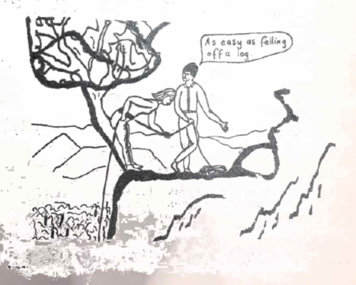

A BUSHWALKER’S SHAKESPEARE
Lyn Stephenson
“Whereto the sessions of sweet silent thought I summon up remembrance of things past; I sigh the lack of many a thing I sought”
‘AND WISH THAT I HAD MADE IT UP THE MAST.’
AND SO, MIGHT SHAKESPEARE HAVE SAID –
ON LEAVING HOME –
“Till I return, of posting is no need.”
ON LEAVING THE MOTOR TRANSPORT –
“How heavy did I journey on the way.”
TO A LAGGING FRESHERETTE –
“What is your substance, whereof are you made?”
AS THE RAIN BEGINS –
“Why did’st thou promise such a beauteous day, and make me travel forth without my cloak.”
WHEN LEADER FOLLOWS WRONG RIDGE –
“And from the forlorn (WALKERS) his visage hide,
Stealing unseen to west with this disgrace.”
CLINGING TO A CLIFF FACE –
“I all alone beweep my outcast state,
And trouble deaf heaven with my bootless cries,
And look upon myself, and curse my fate.”
THINKING –
“Like as the waves make towards the pebbled shore,
So do our minutes hasten to their end.”
ON REMOVING A PITON –
“O, no! It is an ever-fixed mark,
That looks on tempests and is never shaken.”
“and having climb’d the steep-up heavenly hill” –
“… so long as men can breathe, or eyes can see,
so long lives this, and this gives life to me.”
ON DESCENT –
“These present, absent, with swift motion slide.”
ON MEAL TIMES –
“Feedest thy lights’ flame with self-substantial fuel,
Making a famine where abundance lies.”
FINALLY –
“Weary with toil, I haste me to my bed,
The dear repose for limbs with travel tir’d.
And then begins a journey in my head.”
HOW CAN I SLEEP,
“If the true concord of well-tuned sounds,
By unions married do offend the ear?”
THESE CREATURES –
“Do in consent, shake hands to torture me.”
ON AROUSING OUR LEADER NEXT MORNING – AND EACH OF US
“Doth homage to his new-appearing sight,
Serving with looks his sacred majesty.”
BUT IS THIS OUR LEADER WE AWAKED AT 5 AM –
“Or some fierce thing, replete with too much rage.”
DOWN TO THE CREEK –
“To find where your true image pictured lies.”
CAN THIS BE?
“My glass shall not persuade me I am old.”
ON A CHANGE OF OUTER GARMENTS –
“But why thy odour matcheth not thy show?”
AH BUSHWALKING!
“Who will believe my verse in time to come,
If it were fill’d with your most high deserts?”

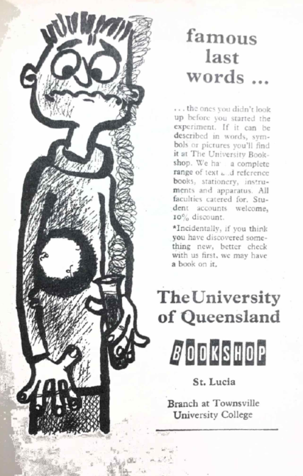

CONSERVATION OF CAVES AT MT ETNA, NEAR ROCKHAMPTON
Michael Graham
(University of Queensland Speleological Society)
At Mt Etna, north of Rockhampton, there are two outcrops of cave-bearing limestone which are of considerable scientific and speleological interest, and which at the moment are threatened with destruction by quarrying operations carried out by Central Queensland Cement Co., and Mt Morgan Mines Ltd. The aim of this article is to show why these caves should be preserved, and to make suggestions for alternate quarry sites. Some of the principal features, cave locations, and mining leases of the area are shown on the accompanying map.
The cone which is Mt Etna is a bold limestone outcrop, a landmark seen for miles around, with rugged rock faces and patches of vine scrub. So far it is unmarred by any quarrying. It contains many caves (some dozen of which are well explored; ten unexplored large entrances; and an indication that many more will be found) supports a large cave fauna, and the surface has a rich bird and animal population.
The Main Cave (immediately behind the proposed quarry face) is the largest in Mt Etna. It is a maze of chambers (60’ high, 50’ diameter) and connecting passages. It features an impressive corridor (40’ high, 10’ x 100’) with side corridors, one of the corners being a tall, beautifully coloured and striated column. Other caves in the same flank of the mountain penetrate known distance of 400’ into, and 200’ down inside the mountain.
Johansen’s Cave in the north end of the opposite ride has a total passage length of one mile. It faces eventual destruction by the Mt Morgan Quarry. It is an extensive and very interesting system with chambers 70’ high, 60’ x 200’, and some beautiful formations in its inner section. It is also the colony cave of Macroderma gigas.
CAVE FAUNA
There are at least four species of bats inhabiting the caves, and it should be noted that bats are protected fauna. Macroderma gigas is a large bat, called “Ghost Bat” or the “False Vampire” with a 2’ wing-span and white over-fur on its body. This bat is rare and is becoming rarer and seems to be facing extinction. It is vital therefore, that their habitat in Mt Etna be preserved.
Mineopteris schreibersi, a small bent-wing bat occurs in great numbers (estimated in one report to be more than 10,000), and has its colony in a cave on the northern face. Since these bats are insectivorous, they may have great economic value in controlling pests. The lesser Horse-shoe Bat and another giant bat are distributed throughout the caves in smaller numbers.
Other fauna include a rare species of frog, numerous insects, various scavenging beetles, hunting buts and moths. All these animals are cave-adapted and therefore provide excellent opportunities to study evolutionary trends and processes. So far these forms of life have had only superficial examination, but there is a growing body of Zoologists and Entomologists working on them. The destruction of the bat caverns would also interrupt the present Australia-wide Bat Research Programme sponsored by C.S.I.R.O.
To aid the study of these and related topics, such as the geology of formation and of ground water processes, the U.Q.S.S. is carrying out cave surveys; having mapped three and having started on a fourth.
CAVES AND SPELEOLOGY
There is a growing interest in caves throughout Australia. Speleological societies are becoming active in all states with the aim of styling caves and providing ordinary people with a very exciting field for adventure. Outlets for active exploration are becoming more important as cities grow and people want outdoor activities, and caves provide a mysterious and luring realm. We should consider this and do our best to preserve as many caves as possible for the enjoyment of our fellows and for posterity.
The caves on Mt Etna are not of tourist class, but have much to fascinate the person with more than a passing interest in caves. There are many beautiful formations – dripstones, stalactites, columns and shawls, and these make exploration exciting. The architecture of many of the large caverns is breath-taking and there is a wonderful field for cave photography.
It should be noted that caves are extremely rare in Queensland. In the extreme south near Texas, there are small caves in a limited outcrop. Extensive caves occur in limestone at Chillagoe and Camooweal. But where are there any caves in the intervening 1,200 miles?
Our society has explored large areas of limestone in the Gympie-Biggenden area, the Boyne Valley, Yarwon, and Many Peaks Range but these areas proved to be uncaverniferous. Thus, the Mt Etna Caves and Olsen’s Caves of the Rockhampton area are the most accessible and almost the only caves in Central Queensland, and indiscriminate quarrying threatens to destroy them. Furthermore, both Mt Etna and the opposite ridge were originally marked on the Parish Map of Fitzroy as Recreation Reserves.
REASONS FOR CAVE CONSERVATION
- The caves in Mt Etna and the opposite ridge are very interesting scientifically and their preservation would allow further studies to be made.
- The caves are of an unusual type, being developed vertically rather than horizontally, and warrant special studies to determine their mode of formation. This work will require preservation of as many caves as possible, especially those caves in the northern face chosen for quarrying.
- The caves are usually rich in cave-adapted animals, and it is fairly certain that destruction of these caves would detrimentally affect the cave populations and the work being done on them.
Both limestone deposits are undoubtedly very conveniently situated for the interest of Central Queensland Cement Co., and Mt Morgan Mines Pty. Ltd. However, as there are equally large and pure reserves of limestones on the northern half of the easterly ridge, the following suggestions are strongly recommended:
- The Northern section of the ridge containing Johansen’s Cave be preserved.
- Mt Etna be left undisturbed and preserved as a National Park.
- That quarrying be carried out in the site of Pilkington’s quarry (now unworked and leased to Central Qld. Cement Co.), where the caves have already been destroyed. It may be possible for the aforesaid companies to form a joint quarrying operation in this quarry or any other suitable site, for example, Limestone Peak.
- Finally, if the above suggestions are unheeded, I suggest as a last resort, that the North-eastern flank of Mt Etna facing Limestone Peak be quarried instead of the north face.
Why must the quarries be sited where they will do the maximum damage?
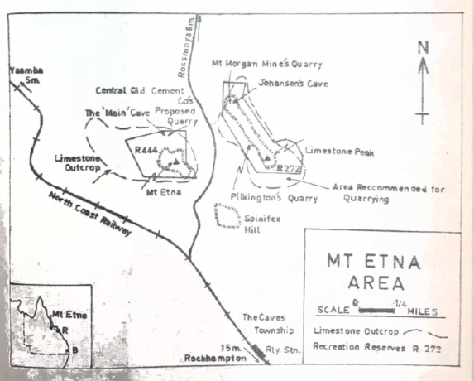

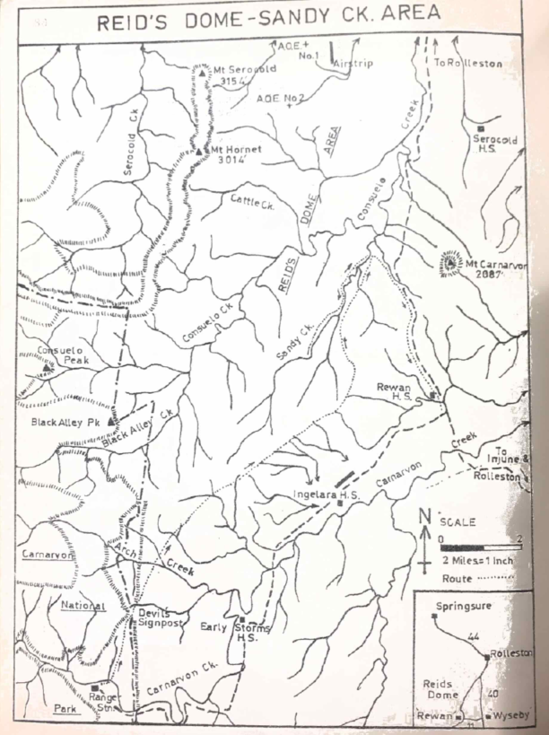

SANDY CREEK
John Siemon
Reid’s Dome, which forms part of the Springsure-Serocold Anticline, is about fifty miles south of the central Queensland town of Springsure. The Dome is a broad asymmetrical arch 4 to 8 miles wide, dipping steeply to the west and less steeply to the east. Fossils are abundant in the area, particularly in Cattle and Sandy Creeks. Reid’s Dome was the scene of oil exploration in 1958, but only a limited amount of gas was found in one well.
This was Reid’s Dome, the area which Garth Forster, Peter Hayden and myself set out to explore, while the remainder of the party enjoyed the luxury of Carnarvon Creek. We had three maps to guide us, but these were not accurate, and it was usually by guesswork that we estimated our position.
Late on Wednesday afternoon we finally left the ‘bus with the comforting thought that it was going to be a dry camp that night. We followed the ridge that left Carnarvon Creek at the large right-angle bend near the Ranger’s Hut and were soon climbing steadily towards Devils’ Signpost. As we climbed higher, the late afternoon sun on the white and red sandstone cliffs presented a beautiful scene. While edging our way round the eastern side of the Signpost in the rapidly vanishing light, Garth’s pack “blew up”, but temporary repairs enabled him to reach safer ground. Our camp that night in the saddle behind the Signpost was not a happy one, as Garth cold not repair his pack and would have to return to the ‘bus.
Unfortunately, we had a good view of the sky, and Garth proceeded to present an astrology – oops! Astronomy lesson. This went on for some time, so I hear – I went to sleep. As the sunrise was not very spectacular, and the air cold, it was some time before we crawled out of our sleeping bags and prepared to leave.
By 9 am we were following a dingo trail along the cliff line. Shortly afterwards, Garth, the last “intelligent” being we were to see for two days, thought he had better start back, and Peter and I set off into the “wild” country. When a break appeared in the quests, we decided to leave the cliff country and healed down to the open areas. The grasslands were soon reached, and a steady pace enabled us to make Arch Creek by about 10.30 am. There was plenty of water about 1 ½ miles downstream from Arch Chasm, although the Ranger had told us we would not find it outside the Chasm. About noon we crossed from “Early Storms” property into “Ingelara” attempting to travel N.E., but the direction of the creeks forced us east most of the time. While crossing one of many creeks, large pieces of fossilized wood were found, which Peter attempted to remove, and shortly afterwards a granite outcrop was discovered on the side of a ridge. This is probably part of a glacial erratic, deposited about 230 million years ago in the Permian Period.
The northern boundary of “Ingelara” was reached about 3 pm and shortly after, to the east, the northern boundary of “Rewan”. Here a road ran alongside the fence, and we decided that it was quicker to follow the road than wander through the scrub crossing dry creeks. While enjoying the luxury of a rest, Peter investigated a disturbance beside the road. An echidna, burrowing under a log, was soon photographed, and allowed to complete its journey. About 5 pm we left the road and followed a tributary of Sandy Creek, but no water was to be found so it was a dry camp again. While restoring some lost energy we were visited by a pair of rock wallabies who decided we were just part of the scenery, and left, and some time later the sounds drifted down from the hills, of wild animals fighting.
Friday morning was very cold, with the sun streaming through the trees and making weird patterns on the ground, and by the time we had packed out gear it was 9.30 and still cold. The presence of cattle and many birds indicated water was not far distant, and after about 1 ¼ hours of easy walking we found cold running water in what proved to be Sandy Creek. After lowering the water level to some extent, we set off eastward armed with a compass to check on our position. While taking a bearing on Mt. Carnarvon to the east of us, I realized the compass was about 20 degrees out (reason unknown)! By walking further east we crossed a creek, and a hundred yards on, a road. With the knowledge that we had only about 7 miles to cover the next day we returned to our packs and were soon moving up Sandy Creek armed with lunch and geology picks.
Cliffs on one side of the creek, then the other, forced us to make a number of crossings, but gradually the country opened out, given easy walking across close cropped grassy slopes and creek banks. Low sandstone cliffs overlooking rapids, and deep placid pools inhabited by ducks and black swans, made the walk very enjoyable. Lunch was eaten on a coughgrass slope in the shade of a patch of cypress pines, with red sandstone cliffs about 100 feet high overhanging the trees on the opposite bank. About six miles up the creek from the camp, a minor accident with a geology hammer forced us to about turn and wander leisurely back to camp. While I collected firewood, Peter climbed a hill just to the north, from where he was able to see Mt. Serocold in the N.W., the Carnarvon National Park and Range to the west, and to the east Mt. Carnarvon.
That night we had the most satisfying meal for three days, and say near the hot fire talking and watching the sky for meteors. A cold morning saw us on our way by 8.30 am and 7 miles of easy road walking were covered in two hours. While waiting for the ‘bus near “Rewan” homestead, we climbed a hill to the S.E., from where we enjoyed spectacular views of Carnarvon Range in the south and west to Reid’s Dome in the north, a fitting end to a very interesting, if dry, trip.
If anyone decides to follow in our footsteps or explore other parts of Reid’s Dome, I would suggest that equipment include a water bottle of at least 4 gallon capacity, a reliable compass, and if possible, aerial photographs, as available maps are not accurate.
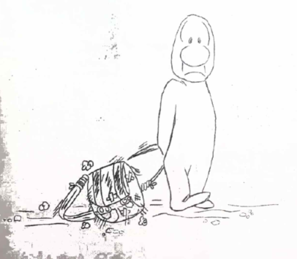
ALONG THE MAIN RANGE WITH A MANIAC
Rosemary Prentice
In the first issue of Mini Heybob, there was a small paragraph about a maniac going along the Main Range in the May vacation. Thinking that the editor was just trying to be funny, I decided to go.
As a first result of this rash decision, I found myself on Sunday night, 16th May, sleeping in a flower bed at Warwick station. We were waiting for the last member of our party to arrive – Dennis, the maniac himself! From there we went in Selwyn’s car (4 people + packs) to the old sawmill at Emu Creek. If you had seen a little green Morris Minor struggling along with what appeared to be a pack on one of the front seats, with long legs and arms spilling out the door, then that would have been us.
But we made it, and next morning we started out bright and early, cheerfully agreeing on “Lizard’s for Lunch”. We followed some branch of Emu Creek past the Steamers, and then having decided that an article in “Heybob” we were using as a guide, wasn’t quite right, set off at right angles to where we wanted to go – I think because it went up! Good lord, what a reason! But, not to worry, of course the leaders know what they are doing.
About halfway up we decided perhaps we were going up Mt Roberts – maybe Lizard’s for tea? We continued on through horrible raspberry, nettles, etc. (without a machete) and nothing very exciting happened – I mean who can call raspberry exciting (whatever else they may call it).
Just as the last light left the sky and we were thinking of torches, we reached the top of what we assumed was Mt. Roberts. As we couldn’t decide exactly where the summit lay, the best thing seemed to be to wait till morning. Anyhow, we were hungry.
Next morning a voice beside me saying “It’s 5 o’clock, people” woke me, and my immediate reaction was to turn over and get back to sleep. However, seeing it was broad daylight (at 5 o’clock?) I managed to shiver and shake out of my sleeping bag.
By eight o’clock we had passed the summit of Mt Roberts. Here Selwyn revealed his true ancestry and climbed all nearby trees (Mt. Roberts is covered with small saplings) to get a view. He assured us it was quite good but for the leaves. From there we went onto Lizard’s Lookout (just 24 hours late). The view was wonderful except that Mt Mitchell looked far more than 2 ½ days away to me.
We hurried on over Mt Steamer and then cut down onto the ridge to Panorama Point. We knew there was water off this ridge to the west and so, armed with soap, toothbrushes, lunch and water bottles, we headed down into the rain forest.
After finding water, ingenious Engineering techniques involving leaves directing tiny trickles of water were employed. As the water dripped into cups, etc., we ate our lunch; when they were filled and had had their photographs taken, we went back to our packs. We seemed to be going quite well that afternoon until the sun set at a quarter to four. All sorts of wild speculation went on to explain this amazing phenomenon. But the explanation was really quite simple. Dennis’s watch (the only one I the party) lost 1 ½ - 2 hours a day!
There was nothing we could do but push on. I had left my torch on in my pack the first night, so I kept getting left behind. From what I gathered later on this was just as well, as the language of those who ploughed ahead through tick wattle scunge and raspberry was not fit for the ears of the young lady. But at last, we reached the cliff line and scrambled up onto Panorama Point. Dennis cheerfully announced it was 5 o’clock. (This boy has a “5 o’clock mania” – far more dangerous to others in the am than pm).
After tea we all crawled into Dennis’s 2 man tent, out of the gale, and went to sleep. Next morning there was a really beautiful sunrise and, one by one, we crawled out again to admire it. Photographs were taken and the distance travelled the day before was suitably commented on.
While breakfast was served, I tried to patch up a rather large hole in my jeans. Rod had been complaining that it smiled at him every time I walked, and both he and Dennis were very quick to offer me some thread to sew it up. For ten minutes I didn’t have to walk last. They even let me lead (through scunge, of course), but after a few small cliff lines I was back in my normal place.
From Panorama Point we went over Asplenium and Huntly. Both have cliffs on the northern side, particularly Mt Huntly. But Selwyn of course, found a way down. He ran up and down it a few times, with and without pack, for exercise, while we decided if it were possible for two normal people plus a maniac with a bad finger. It was, and about half an hour later we continued on our way.
The view all the way along the Double Top was marvellous, and the only thing wrong was that someone had filled all the open forest in with rain forest. U had been under the mistaken impression (only because I had been through there the year before) that there was open forest all the way, so we were in for a bit of a shock.
That night we camped down in the rain forest on the northern side of Double Top. Selwyn excelled himself by making instant potato that wasn’t soup! Dennis had managed this very well the night before. He muttered something about sabotage…
But then – what would you expect from a maniac who initials all his M&B tins! Actually, this would be good if he could spell, but V for promote? Rumour hath it that he caught the sickness from his mother. Apparently, if you starch around in his hair you can find ‘D.T.’ initialled on his head. I can’t prove it, as I’m not in the habit of taking ladders on bushwalks – hey, wouldn’t they be handy for cliffs, and we could put an ‘L’ on it too!
But back to our little jaunt. On the next and last day, we went through Spicer’s infamous Gympie patch. A consolation to those who always end up walking last – at least all the Gympie have bene located.
The view from Spicer’s Peak was a bit hazy but well worth photographing. After the inevitable fizzy, we went back along the saddle and slid down into Spicer’s gap. Last time I was at Spicer’s Creek there was enough water to have a good swim and so I cheerfully reassured everyone that, after not seeing water for 1 ½ days, we would have miles of it. We walked back about half a mile and found one stagnant, 6 inch deep, slimy pool. All the water had to be boiled and even then, the bright green froth that came to the top when the billy boiled sort of hit you in the eye. But this led to exciting experiments such as fizzy and hot water, and then, even worse, fizzy and tea! (Of course, it was undrinkable).
From here, the party degenerated even further into a free-for-all raisin and died apricot fight. One way of losing weight out of a pack, I suppose.
At last, we decided it was time to move and began the last awful steep climb up grass slopes onto Mitchell walking tract. We got to the summit of Mitchell just before dark. I can assure you that Mt. Roberts looked a horrible long way to me.
From Cunningham’s Gap we hitchhiked back to Warwick. Here we celebrated our return in Don Hitchcock’s flat while he and Selwyn braced the freezing night air to get Selwyn’s car back from Emu Creek.
We all managed to fit in Selwyn’s car going home, even all the arms and legs, and, despite the maniacal driving of one who thought the Morris Minor was a jeep, lived to tell the tale of yet another memorable trip.

A BRAVE LEGEND
Two Red Indian braves, Running Water and Falling Rock,
were both in love with the same maiden, Soft Feather. She
could not decide between the two hunks of bravehood, and
consulted her wise old father, the Chief.
He set a tough course for the two swains through the
hills and valleys of the land, the first home winning the hand
and the rest of Soft Feather.
Running water returned after many months, and duly
claimed the girl. Falling Rock never returned. Foul play was
suspected, and a wide search was organized, which is why, even
today, you see so many signs “Lookout for Falling Rock”.

MORE STORIES FROM RON COX – OR ADVENTURES IN THE FRENCH ALPS
Grenoble, le 15 juin.
Dear Pat, Grahame, Pete.
Have been having a fairly hectic life lately, nothing but working and climbing. It’s rather fatiguing, but fills my definition of living. I’ve been working long hours at the Nuclear Centre, mostly at night. In order to get a particular spectrometer, kept running hot by a lab full of chemists in the day, I have to work nights.
A couple of weeks ago I judged the time ripe to let it leak out at work that I had a vague interest in doing a bit of climbing. Soon after, the bloke in the room next to me at the Nuclear Centre, who is the president of the local Groupe Univesitaire Montage-Ski (GUMS’S), invited me on a weekend club trip. We left Grenoble in several cars after lunch on Saturday and drive some 80 km into the massif of the Oisans. The Oisans, as I may have mentioned are, after Mount Blanc, the second range of France, and include peaks of over 4,000 meters such as Meije. We, however, were only going to the smaller stuff.
From where we parked the cars, we took just over two hours to climb 3,500 feet to the Refuge Soreller; such climbing rates are possible without undue fatigue because the tracks are so beautifully graded and are fairly smooth. The “Refuge” was hardly a “hut” in the Australian or Kiwi-sense. It was a new, three-stories stone palace with Laminex-topped tables in the dining room, etc., and capacity 60 people. Everyone in the hut went to bed before 9 pm, just like N.Z. No one thought of staying up to swap stories around the campfire; there was no camp fire.
Our party rose at 5 am. I got up a little easier to prepare my porridge, imported from Scotland at formidable expense. The rest of the party being French, went out for their day’s climbing with nothing more substantial in the stomach than a cup of tea. I could only get through half the big billy of porridge I made, but it was impossible to give the rest away. The only thing more un-French than breakfast is porridge for breakfast! Needless to say, everyone winged all day how hungry they felt, but the idea of eating in the morning is completely alien.
I led one of two ropes of two on the Aiguilla Dibona, a sharp, granite crag some 1,000 feet high. I was a little worried, first, because it was my first climb in France and I didn’t know how my standard would compare, and secondly, because it was only one day after the expiry of the period during which the Doctor said I mustn’t do anything violent with my ski-accident-injured knee. We started off up snow, then moved together on easy rock to the start of the real climb. The Oisans Granite is somewhat different in texture and quality from Chamonix, so they say – certainly nothing to rave about – but, in general, it was solid. The first two pitches went alright, but on the third I got into strife on wet, rather holdless rock, and screamed for a top rope form the other GUMS’ rope above. This was rather cowardly, but my moral backing was not too good. My second young and female and could hardly be expected to hold a falling leader on the inadequate, French-style belay she was using. The top rope duly came down and I surmounted the difficulties, but my morale was not greatly improved by being informed that the pitch had only been of Grade III. However, I had no serious trouble on the rest of the climb including the hardest pitch which was of IV. The entire climb was graded as AD – i.e. “assez difficile” – literally, “Rather difficult”. The grading scheme goes PD (peu difficile), AD, D, TD (tres difficle) and ED (extrement difficile).
The sight of French belaying is something to write home about. It’s extraordinarily sloppy. The belayer hitches to the anchor pegs, and hitches the rope to the climber to the same peg. The rope is usually held in a shoulder belay (See fig.).
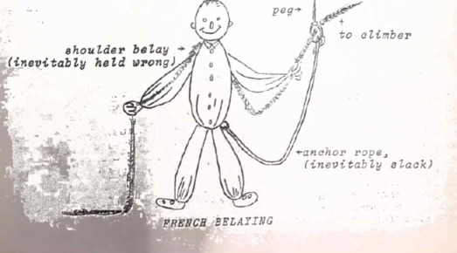
It’s good if the peg holds. Many of the pegs, which are usually in place, look very unsafe, but no-one ever bothers to give them a tap to tighten them up. Any sort of a peg is regarded as a point of complete security. By contrast, rock spikes are instinctively distrusted, and running belay slings are almost unknown. The French and British attitudes to belaying are completely different. For example, Gaston Rebuffat’s textbook, “Roc et Neige” gives only about half a page to techniques of belaying.
We were, for various reasons, a rather slow party, and half-way up, people started to catch us up from behind. It became quite crowded and the “Excuse me, would you mind not stepping on my foothold” conditions were sometimes annoying, but more often quite amusing. After talking in my stilted French for some time to the leader of one rope behind, we both discovered we were British. This later proved useful when I was well above my second, and she couldn’t understand my shouted, badly pronounced instructions. So I would shout down in English (somewhat more intelligible over a distance) to this Englishman who was near my second – “Please tell the young lady to untie and come on up” etc. and he would translate into French.
When we finally gained the summit, after 5 hours of climbing, it likewise was crowded. Fortunately, it had been snowing off and on early in the morning, which had frightened many people, particularly the CAF, back into the hut. The GUMS looks down on the Club Alpine Francais (CAF) in much the same way as UQBWC and Tas. Uni. Look down on --- and --- respectively. The similarity is quite striking; the CAF is mostly comprised of old men, teenagers and babies in arms and is rather unadventuresome, but this is not surprising, considering its huge membership (40,000 odd).
The air was warm, and cloud hung low overhead, threatening a thunderstorm, so, as soon as possible, we started down towards a col on the opposite side of the mountain. One abseiled two lengths from the summit. Again, we were rather slow, and this caused some ill feeling. A party behind on the summit, waiting to descend, suddenly started abusing us, screaming at us to get off the rope because they reckoned, they could hear electrical discharge buzzing about their ears. We pooh-poohed them, as there were no thunder or lightning about, but we hurried down, and they came down the abseil like madmen, quite panicked. I was quite relieved when they got down; at the speed that they abseiled I feared greatly for their safety. You see, everyone here abseiled of nylon line sling, about 5/8” circumference! That’s France!
From the col we descended easily to the snow and trudged down to the refuge, sinking only occasionally to the waist. Then, home to Grenoble. The trip was quite good, even if the summit gained was only 3,200 meters. However, since I’d found an “Assez dificile” climb rather more than “rather difficult” I developed some fears about my ability to do major climbs.
Since then, I’ve down three other climbs, all on lower mountains, and all harder but less entertaining and, not wishing to overbore you, will leave any description to, perhaps, a later letter. I’ve led a couple of pitches of V and gained some confidence. Much of my difficulty on the Qiguille Dibona was imply “start of the season stiffness”, a malady everyone here is complaining about.
A young English chap – student at U. of Grenoble – was killed in a fall on snow on the Grand Pic de Belledonne last week. This is the highest peak visible from Grenoble, 12 ½ miles from town. He was 18 years old. At least the local newspaper had the decency to write him a rather tender epitaph, in striking contrast to the soft of write-up that, say, a Christchurch paper would give the death of a foreigner. (I hope I’ll never have need of a tender epitaph).
You mentioned hearing of an Eiffel Tower climb. This was broadcast to Eurovisian’s 80 million viewers. The party was Guido Magnone (leader), Rene Demaisons (a fairly big name these days; has the “R.D.” climbing shoes named after him), Robert Paragon and Ian MacN’eught Davis. The latter is, presumably, a hairy man from north of the Tweed. It was interesting to read a strong criticism of the climb in the Grenoble newspaper. In an editorial article, the paper grumbled it was alien to the spirit of Alpinism, sensation and publicity hunting, and if this sort of thing kept up, we would hear next of Walter Bonatti doing the west (overhanging) face of the Pisa Tower, etc. Such a commentary in the Grenoble newspaper shows how mountaineering-minded the newspaper presumes its readers to be.
Lionel Terray is in Alaska to try a new route on Mt. McKinley. He has taken along 60 kilograms of French sausage, which is apparently essential to keep Frenchmen going.
Thanks, Pete, for your recent letter. Sorry to hear you’ve more or less given the sandstone away, although by the sound of it, it’s not the world’s best climbing rock. Perhaps the thing to find is a Fontainebleau style climbing garden of sandstone where the looseness of the rock wouldn’t matter. I can’t see that you have any reason to bemoan missing out on going to Ball’s Pyramid. I’ve seen pictures of it, agree it’s spectacular, but you’d get far more climbing in Kiwiland. I’ve seen similar Karakorum slides to Budd’s, by Geoff. Bratt of Hobart who was also on the expedition (but I thought Stephenson’s slides were far better than Bratt’s).
I agree with you about Mount Blanc looking high and incredible at first sight. Although it’s rather domy, there’s nothing in N.Z. which compares with it as a big bulk of ice.
Thanks also, Pat, for your letter of a couple of weeks ago. Would you send me Titus Kirk’s address some time? I haven’t heard from him, but I’ve never written to him. nor have I heard from Peterson. (I hear from Fred Mitchell that Wilmot, who is in Montreal, has met him, so, presumably, he hasn’t yet been taken by a polar bear or overturned his canoe in deep water). I’ll think about a magazine article, but have yet to do a trip worth writing about.
I suppose one of these days I must try to describe life in a French Laboratory. It’s sometimes quite entertaining. However, for me at the moment, it’s rather hard work, to which I’m most unaccustomed.
Ah well, must go off for my evening run around the block, training for the Grepon next weekend.
See you. Ron

July, 5th Grenoble
Dear Pat, Graham, Pete,
I suppose you’ve not been greatly interested by previous accounts I’ve written of mountains you’ve never heard of. This letter may be more interesting, as it’s about a more well-known mountain, The Dru.
Unfortunately, I can’t describe to you a successful ascent of the Bonatti route, or anything else similar. Instead, I have to tell you that I failed on the ordinary route. Oh, humiliation! I went with a chap called Yves Mareschal, a chemist at the Nuclear Centre who has done a fair bit at ‘Bleau and Chamonix although, being married, he’s a bit out of training at present.
More of less to get acquainted, Mareschal and I did a short climb one night after work on the Trois Purcelles, a group of limestone crags, at about 4,000 feet, above Grenoble. Apparently, he was satisfied with me, because he thereupon invited me to the Grepon. The anticipated weekend, the weather looked bad, so we stayed in Grenoble. On the Saturday we went to a crag called Chamechaude, but it started to rain just as we go to the foot of the climb. I thereupon insisted that we go to the 2,000 metre summit by the ordinary route. Very reluctantly, Mareschal tagged along. We didn’t quite make the top; the rain got heavier and heavier and forced a retreat. In descending, we got half drowned, and Mareschal muttered allusions as to how, in all his experience, the only people who went out in the rain like this were British. The Sunday turned out to be fine and we went south into Vercors Massif to try a magnificent Dolomitan style wall a thousand feet high and Kilometers long. Here , because we started late and couldn’t find the route, we only got up a few rope lengths, then gave it away.
After this, despite the fact we hadn’t really established we were a team, Marechal decided we would bypass the Grepon and do something harder, the Drus traverse. To put this Dru attempt in its correct perspective, I should mention that, in the last month or so, apart from the vague excursion mentioned above and the Aiguille Dibona trip described in my last letter, I did two fairly successful climbs of “Difficile” standard. One was mount Aiguille, a peak incredibly similar to Crookneck in appearance, but three times the scale. This I did with an English electrical Engineer whom I’d met on the Aiguille Dibona trip. (This bloke, like everyone else, is here for the mountains, and because there is a strong demand for good jobs in Grenoble, he is reduced to all sorts of bum jobs, at present translator, to stay here). The other climb was a traverse of a couple of the Aiguilles De l’Argentiere, a smallish group some 30 miles away, very similar to Geryon. I did this with a bloke who’s never climbed on a mountain in his life but was a whiz in the Grenoble quarry where the local lads all train. Thus, he couldn’t understand why I was horsing around so much leading on what, to him, were just ordinary problems – I’ve never had such an unco-operative second!
On these various climbs I found I could lead Grade V, if with difficulty. Grade V is where it’s just starting to overhang and tends to be strenuous. I’ve not yet found any delicate climbing in France, either on limestone or Granite. When Mareschal suggested The Dru, on which the hardest pitch is of IV, I, therefore, thought I could do it. This was wrong. I didn’t realize the immense difference between “difficile” at Chamonix, and “difficile” on the 2,000-3,000 meter stuff near to Grenoble, such as I’d been doing.
We left Grenoble Saturday morning, June 27th, and were at Montenvers about 11 am, stared at by hundreds of tourists. From Montenvers one descends onto the Mer de Glace and follows it upstream a couple of miles. It’s the flattest and smoothest glacier I’ve ever been on. Then you climb up an easy 3,000 feet into a side valley to Charpoua Refuge, a CAF hut for some 15 people. The hut as deserted. It appears that the area has a certain aura of difficulty – rather like the upper Hooker Valley – and is not very popular. Certainly, the immense walls of the Dru, the Verte and the Moine, which soar above the refuge on three sides, are a bit frightening.
We arrived at the hut just in time to beat the traditional afternoon thunderstorm. After it cleared, we went up to a vantage point and vaguely viewed the route. Then returned and got to bed about 7 pm, whereupon four loud-talking Geneva Swiss arrived and kept us awake till about 10 pm. Gurr! Started at 2.30 am next morning after a breakfast of porridge which, although he is French, my friend claims he likes. Wasted about two hours sorting out a route across the slots and seracs of the Charpoua glacia. By the time we got onto Dru rock it was sunrise – rather beautiful on the arc of the mountains from Mount Blanc to the Jorasses but rather disquieting, since, at this hour, we should have been much higher.
I have drawn below the Charpoua side of the Dru.
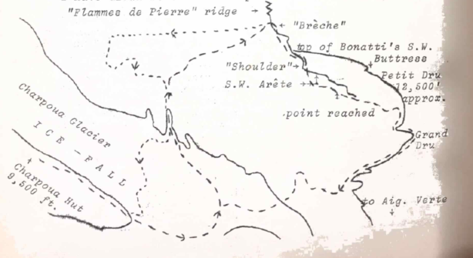
The Drus traverse is fairly classic but, as late as 1925 – the age to which Frison Roche’s famous novel “First on the Rope” applies – it was considered as amongst the biggest undertakings in the Alps. Now it is rated as “difficile” which is one grade less than the north Dru (T.D.), and two grades less than the west face or the Bonatti route (E.D.). Still, it is considered quite hard. The Guidebook says 6 hours to the top of the Petit Dru, and 12 hours (refuge-refuge) for the traverse. To do these times there is only one solution – run!
We, unfortunately, were not capable of running. On the easy rocks between the Charpoua Glacier and the Breche, one should move together, except in one or two odd spots. Since I was not used to moving together on rock, and since we weren’t a s smooth, old established team, we did most of this in pitches. Even though we “led through” it is very much slower and very much more tiring this way, in addition, we made route finding errors, seemed always to find the hardest way, and by the time we hit the Breche it was very late – 8.30 am.
Here we paused to stare in awe at Bonatti’s S.W. Buttress, only a few hundred feet away. I suppose an almost perfectly smooth and linear column, broken only by occasional overhangs, 2.5000 feet high and tilted at 85 degrees, is not so very remarkable. What is remarkable is that one man climbed it, alone, spending day after day at the very limit of human powers. Then we looked down the plunging chute between us and the S.W. Buttress, and wondered how he could get the courage to abseil down there – alone ! Because the lower part of the West Face had recently slipped, making access to the S.W. Buttress near-suicide (a relative term!) Bonatti came up the ordinary route from the Charpoua to the Breche and abseiled down the couloir to gain the foot of the Buttress. All alone, and all with a 60 lb pack.

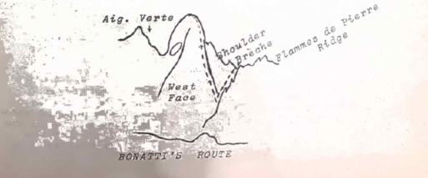
Such reflections made cur puny efforts to get up the ordinary route seem laughable. We had, so far, taken more than twice the guide-book time, and hadn’t ever started on the difficulties. We continued on up the S.W. Route turning round a big gendarme, and gained the “Shoulder”. Above here, the wall really shoots up, and here commended us 800 feet of continuous difficulties – all Grade III and IV. We struggled up some 400 feet, getting tireder and slower. Being second, I had the heaviest sack loaded with crampons and ice axes (necessary for the descent, if we did the traverse), spare rope, etc. The sun blazed down mercilessly as we climbed cracks and chimneys, and we sweated away out last strength. We were just too slow and about 11 am, with 400 feet to go, realized that if we went on it meant a bivouac.
Sat on a little terrace – the highest point reached for a half hour – eating, feeling glum and demoralized. Fancy falling on the ordinary route on the Dru! Before us, a vast panorama of half the mountains I’ve ever dreamed of – Mount Blanc, the Aiguilles, the Geant, Grandes Jorasses – I hardly saw them; I don’t think I’ve ever climbed on a mountain seeing so little. Absorbed by the climb, I‘d hardly lothered to even look, and took very few photographs.
We started in long rappels, to the Breche. I’m getting quite French. On my first climb in France, I was shocked to see people placing nylon line slings for rappelling off. On The Dru we rappelled several times off slings that had been hanging there an unknown time, and I hardly even complained! (Frenchmen, incidentally, have never heard that there is any danger of nylon slings melting).
On the last rappel, the rope stuck. It took me an hour’s quite desperate work to get it down. That finished me. Up to this time, we had both worked – sometimes Mareschal would be leader, sometimes me – but after that I followed along, a very docile second, hoping he knew what he was doing.
I might mention that on this climb we used no pegs except for a couple of abseils. It was great to climb in classic fashion. I remember particularly the tremendous feeling of satisfaction we both felt to overcome one difficult problem by the time-honoured technique of giving a shoulder.
From the Breche, we moved together nearly all the way down. Soon we were enveloped in thick mist, and wandered about all over the place (As shown roughly by the dotted line on the diagram) trying to find the exit on to the glacier. In the mist it was very dark, and I feared all the time that we’d be benighted, although, in reality, it was still quite early. Later, there was a brief fifteen minutes hail-storm which completely soaked us, and made it imperative to get off the mountain. Fortunately, the mist cleared enough after the storm to give us a view, and allow us to gain the glacier.
Here we decided to cross the glacier at the lower level, since our morning route went for some hundreds of yards over the debris of avalanches which came off the Verte. It proved to be very difficult to cross, particularly since snow and ice alike were in the worst conditions I’ve ever met - somewhere between porridge and soup. at the last ice-wall before the opposite bank, Mareschal was buggered momentarily and I had to call up my last initiative to struggle up it. It was almost unpleasant in the glacier, lost in the mist, shivering in wet clothes, afraid of the approaching night; and we were glad to get out of it.
Ran down the ridge to the Hut, where, since we were weekend climbers, there was no rest. We had to get back to Grenoble. Bu the time we’d descended the 3,0000 feet of rough track to the Mer de Glace, it was almost dark, and I was finished. Fortunately, Mareschal had recovered by this (it was astonishing how the leading ability changed hands several times on the trip) and by almost miraculous navigation, he found the way down the Mer the Glace to the steel ladders which head off the ice near the Montenvers. It was pitch black, and he did well to find those ladders. I merely staggered along behind, like an automaton.
We rolled into Montenvers, asleep on our feet, collapsed on wooden benches at the railway station. It was 11 pm. We’d been marching 20 hours almost non-stop, and there was no question of going home to Grenoble. Slept until 4 am, woken every hour or so by the cold (what must it be like a few thousand feet higher?) and in first light ran down the railway line to Chamonix. (That run in tight “Toni Egger” boots crippled me and I’ve had to wear slippers to work all week). Got back to Grenoble about 8 am, just in time for work. Mareschal had an interview with his Prof. at 10 am, which was why we absolutely had to get back. I went to work, but was totally unable to do a thing all day. Fortunately, at lunch time there was a Champagne party to celebrate someone’s wedding, and at least in the afternoon I was happy in the knowledge that no one else could work either.
The post-mortems on this trip have been long and profound. I’ve more or less decided that I was biting off more than I could chew in attempting the Drus. There is some excuse, in that weekend climbing is a fair shock on the system after a sedentary week. One cannot really get fit and stay fit in the way that is possible on an extended climbing vacation. And living in the blazing hot valley of Grenoble one cannot acclimatize, either. However these excuses don’t avoid the indication that I’m not good enough to do long routes of “D” at Chamonix. My boss, who’s done a bit, gave me a bit of a peptalk at work one day last week – reckoned I should stick to easier stuff for a while, and learn to move fast before trying the harder classic routes. He’s right; to do the times quoted in the book for Chamonix climbs, you’ve absolutely got to be able to run. I don’t know whether you found this when you were here, Pete. Did you ever do anything labelled “D”? did you find you could do the guide-book times? It seems to me that the times quoted are the times for parties thoroughly competent at the level of difficultly involved, in order to scare incompetent parties off the climb.
Alpine News: A Chanomix guide, and an American J. Harlin, put a new route up the W. Face of the Blaitiere. They claim it is harder, at least for the artificial sections, than the “Brown-Whillans” route on the same face. (The Brown-Whillans route, with its famous “Fissure Brown”, is said to be inaccessible due to landslips. It was long considered as a contender for the hardest route at Chamonix. In its clean state as the English did it – i.e., 10 pegs and one wedge – there were 8 pitches of VI. The difficulty varied, depending on how heavily it’s pegged).
Gaston Rebuffat had a serious prang on the Dent du Geant last week. Appears he was leading on artificial when a whole row of pegs came out, one after the other. He, his client, and the second guide, fell 150 feet into a snowfield. They were sliding off into the wide blue yonder when a quick-moving guide, leading a party just behind, fielded them on the snow. He ran to the Col de Geant and called up a helicopter which had them in Chamonix in two hours, despite high winds. (Most recues are by chopper these days). Rebuffat had discs broken in his back, similarly the other guide. The client, a 64 year old Englishman, had mild concussion. Whether this will finish Rebuffat’s career is now known.
The “last great problem” of the present day is the Eigerwand Directissama – the original Eigerwand route winds all over the place and it’s considered to be time someone put up something direct. Rene Desmaisons, France’s star of the age, got about a third of the way up two weeks ago and is back there at present, accompanied by another Chamonix guide and the abovementioned American, Harlin. This Harlin is a Yosemite Valley man and has been around a bit (Eigerwand, new route on Mont Blanc massif notably the S. face of the Aig. Du Fou, considered to be the hardest artificial climb at mount Blanc and Dolomitan is standard). Like most people who attempt routes of such magnitude these days, they carry a two-way radio. I can see the day will come when the use of radios becomes general (in the same way that the little while helmet, once the mark of the Eiger climbers, are getting to be worn by anybody, including me, these days). Then, if you get into strife on the climb, it will be necessary to get on the blower to Chamonix gendarmerie and their helicopter will whip you off in a matter of minutes! Ah, the march of progress.
What’s this shocking news I hear that Conaghan and Hardy are planning to rawl-plug Tibro – to think it’s going to be turned into a sort of Queensland Yosemite Valley! Still, I suppose you’ve got to do something.
See you.
Ron.

Chez Page, 93 Rue Ampere.
Grenoble (Isere)
8/11/64
Dear Pat, Grahame, Pete,
Am feeling a bit perkier these days, having done my first “T.D.” (tres difficile climb) last weekend. There is a great difference in the social status of TD climbers and that of the average climber who occasionally does a climb of D, but never anything harder.
Of course, the said TD climb turned out to be the usual bungle. I went with a young CAF chap who is an electronics technician at the Nuclear Centre. He is considerably better than me and has done a fair number of TD climbs. Our mountain was Mont Aiguille (2080 m) which I once described to you as being very similar in appearance to Crookneck, but on three times the scale. There had been a very heavy snowfall days before and everyone was telling us that we were mad to go, the season was finished, there’d be snow and verglas feet thick on all the rock, etc. etc. People have exactly the same wet blanket tendencies here that they have in Brisbane, Hobart, or anywhere else. In fact, during those five days since the last snowfall, the sun had been shining on the mountain, and our route, which was on a south-east face, turned out to be bone-dry. We started on the rock at 9.30 am, having left Grenoble at 6 am the same morning (Saturday).
There were, roughly, 700 feet of sustained difficulties – much IV, V, and some artificial – on a fairly vertical, limestone cliff. We alternated the lead, and the nastiest bit for me was a spot of delicate grade V which involved some tricky footwork while hanging on to nominal handholds. It took me nearly half an hour to work out how to do this, and to summon up the necessary courage. I was dreadfully afraid that the other bloke, coming up second, would find this easy, thus causing me to lose much face. So, when he arrived at the difficulty, I invited him to pull on the rope to save time, which he innocently did, afterwards saving how difficult it must have been for me without a rope to pull on.
We were both carrying sacks which proved a nuisance; the leader would climb without sack and sack haul, the second would climb with sack. On the second-last hard pitch, sack hauling proved impossible, and being second, I had to climb with the two sacks, one stuffed into the other. This pitch more or less finished me for the day, and left me wondering how I will fare if I ever want to do long, hard routes at Chamonix where you have to climb with a very heavy pack and there is no time for sack hauling. After that pitch, I suffered from cramps in the fingers and arms, which proved troublesome while I was belaying the other bloke on the next pitch, which he led, a wall in A1 and A2, 15 pitons with exit in V. The cramps in my hands would cause them to lock on to the ropes I was giving tension on, which was all very well until it came to paying the rope out, when I would have to use one hand to unlock the fingers of the other. This was the only long, artificial pitch of the climb, and was reasonably easy, since all the pitons were in place. After that, a little scrambling brought us out on the summit plateau. It was just sunset; we had taken 8 hours – twice the book time – mainly due to my slowness while leading, and the number of times that I tangled the ropes.
Having arrived on top, we were not out of the wood. As I said, the mountain is similar to Crookneck – that is, it’s steep on all sides. It was, therefore, much like arriving at the top of East Crookneck and having to go down an ordinary route three times as high as Crookneck’s and, being a north side, O misère, all plastered with snow and ice. Still, we would have made it, had we been able to agree on where the ordinary route was. Unfortunately, we had conflicting ideas. I reckoned it was a gully which I’ll call gully A; the other bloke reckoned it was gully B; after much argument, we started down gully B. after 300 feet of descent, the other bloke decided, no, it really was gully A after all, whereas I had changed my mind, and now reckoned it was gully B. more argument, then back we went up to the summit plateau to peer once more down gully A. full of ugly ice, it was certainly much less inviting than the other, which was cleaner, and so back we went down gully B, only to run into cheeriness, darkness, and no sign of the Ables which are fixed across the difficulties of the ordinary route. We had been wandering about in near darkness on iced rocks and snow, tied together but not belayed, and I decided it was getting past a joke, so back we went up to the summit to bivouac.
Apparently, it was 1 degree C in Grenoble that night, and we were about 6,000 feet higher, and quite unprepared – having a sweater each, but no duvet, dry socks, etc. We kept alive by a simple expedient which I recalled having learnt in my youth – we made a fire. Here and there on the fairly extensive summit plateau, where it was not covered in snow, were enough stunted, dead bushes to make two or three hours’ fire. When this was near exhausted, it seemed that we were in for a miserable night, but, out looking despairingly for more wood on the fairly extensive plateau, I tripped over a fallen Trig. Poet – a long bit of 4 by 4 with a wooden triangle attached. Using pitons as chisels and wedges, we split up all this wood and were able to keep a small fire gong all night. It was still cold, and it seemed the longest bivouac I’d ever experienced – the nights are long at the end of October – but it would have been considerably less comfortable without the fire. Being very thirsty, we were able to melt snow in the cleanest can we could find amongst the summit refuse. It was a most unusual bivouac for my French friend, who had never head of fires, and was filled with admiration at my skill in keeping one going all night, which compensated somewhat for my poor climbing performance. I explained how, in my country, the indigenous peoples, having neither habitation nor clothing, keep themselves warm at night beside a fire. (Actually, the idea of lighting a fire was inspired by an improbable book I recently read in which two climbers, caught out high on the Dru. Keep themselves alive by burning their ice-axes!)
Came daylight, and four hours’ mucking about got us off the mountain. We were back in Grenoble about 1 pm, feeling very tired, but me feeling more cheerful than I’d felt for months, climbing has been dogged by almost continuous bad weekend weather since the end of August, and I had been feeling very frustrated. I hope to continue to climb, although there is great pressure from the more restful sport of skiing. At least, I have done my TD, which is important to me. Actually, I should mention that, comparing wit this climb, East Crookneck, and probably Desperation Wall, would be TD climbs, although it’s not usual to grade short climbs in that way. The delicate horizontal traverse on the first pitch of East Crookneck would be grade V and much of the rest of the free climbing would be of IV; a lot of the artificial climbing would be A2 – certainly, such moves as the movement over the overhang about ten feet below stance 2. This sort of continuous difficulty would quality it to be called TD, perhaps even TD sup., if it were longer. (I don’t know if I’ve ever mentioned that SW Nazomi and the Bowie Ridge would only be ordinary D).
I hope, Pat and Grahame, that you are progressing on the north side of Tibro. You are lucky that you don’t have to be troubled over there by grades and standards, and, above all, times. It would be nice to be able to climb in the leisurely Queensland fashion once again, starting late, etc. the route that you are doing certainly looks spectacular on the postcard that Pat sent me. I have just received this year’s magazine (Heybob) which proves to be interesting. However, it seems that we have just about worked all the past expeditions to death, and someone will have to start doing some new ones soon to provide material! It’s nice to see that we’re starting to get a bit of advertising revenue at last. It’s nice to see another excellent Rosser article. I think – although we probably all suppose that we ware the best writer that Rosser has always been the star, ever since his classic “Mists I have seen …”. I enjoyed your article very much, Pete, but I’m sorry to see that neither Conaghan nor Hardy have contributed this year. The only trouble with the magazine is that there seem to be, each year, more and more articles of the “how Lucy burnt the instant pud” type. I am a bit worried that my old Prof. ….. or someone, may get hold of a copy, and read this letter of mine that describes how I am only keen on magnetic resonance because it’s near the mountains.
Skiing has started properly; the climate rushes towards full winter. For weeks, Grenoble has been submerged in fog – an early winter phenomenon. The top of the fog is at about 2000 – 3000 feet so that, if you drive up into the mountains a bit, you come out above it. The forests on the lower ranges are very beautiful now, with the autumn colours at their peak. Temperatures are getting fairly cold: the lasses have changed into ski-clothes, as town wear. In the last heavy snowfall, about two weeks ago, the snow came down to a few hundred feet above town. The surrounding ranges once more look very attractive on the rare occasion when the fog clears to reveal them. Guess I really will have to put on skis soon.
See you.
Ron
(Prior to this last climb on the Aig. Aiguille, Ron made successful ascents of both the Petit Dru and the Grepon, the latter with Mrs. Dot Butler of Sydney. P. Conaghan)

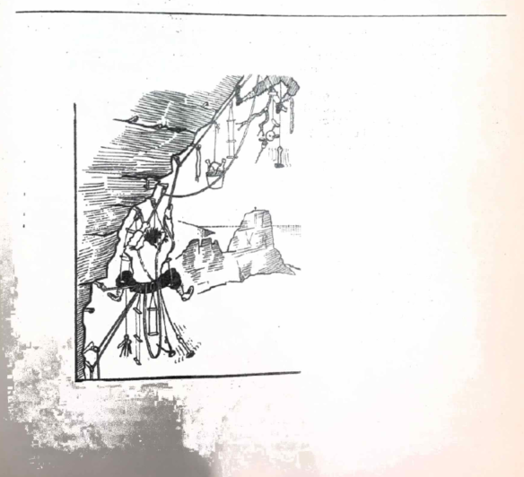

“THE WIDGEE TRIP” – OR, “HERE WE GO AROUND THE RASPBERRY BUSH”
Ken Grimes
This circular said: “This trip is to be run in overdinishing circles, starting at Albert River, and including Mt. Widgee, Lost World, and finally, disappearing without trace into Black Canyon.”.
Little did its author realize how close to the truth he had struck.
We arrived at the Albert River on Friday night with a party of 20 strong (plus one dog). In the morning, we revelled at the thought of a single party of this size, and two breakaway groups developed. One group went to Christmas Ck and our group decided to do the planned trip in reverse. In the end, only 3 went on the original trip, and after a day’s scunge bashing on Widgee, they gave up and returned to Brisbane.
As some fool had got everyone up at daybreak, we got off to an early start and reached the Lost World campsite at 10 am. We had morning tea, which extended into lunch, so that when we got moving again, it was 12.30 pm. In the Lost World rainforest, we had our first taste of what was to come. We were happily weaving our way towards the saddle when, suddenly, Trevor said that he could see “great pastures” where the forest on the side of Black Canyon should have been. From this, we inferred that we were on the wrong side of Lost World and going in the wrong direction. An about-turn, followed by a semi-circle, brought us to the position where we were on the right side, but going in the wrong direction. Another about-turn, followed by some more careful navigation, finally brought us to the saddle.
We commenced to slide down the side into the canyon, accompanied by large rockslides generated by certain members at the rear of the line, who appeared to want to fill in the canyon.
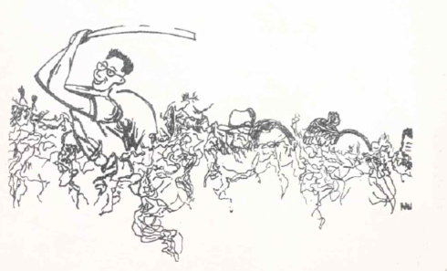
By now, the weather was starting to deteriorate, and as we knew that the quality of the campsites would become worse as we went up the canyon, we decided to camp on the creek when we reached it. Dinner was followed by a rea-drinking marathon, in which we stood around the fire in the drizzle and tried to dry first one side, then the other, of our clothes. Finally, we decided that the fire and the rain had reached an equilibrium as far as drying things was concerned, and we retired to bed. During the night a crayfish with “ten inch feelers” tried to go to bed with one of us.
The weather improved for a while in the morning, and we rock hopped up the creek until we reached the Redrock Falls. We had to wade to the base of these falls balanced on a submerged log. From here on the going was easy, and we soon reached the Falls where one brave person went for a swim in the refreshing water. We returned to the foot of the track up the side of the canyon and had lunch. The rain started just as we were finishing. We crawled up in the mud and rain, passing a previous campsite which had old memories for two of us. When we finally scrambled up the last few yards onto the tourist track, we were immediately set upon by a horde of leeches. Partly because of this, and partly because some fool up the front thought we were running late, we set off for Ratatat at a brisk trot.
When we reached Ratatat we found the Christmas Creek group (plus the dog) had arrived before us, and taken over the hut. We were told that, as the dog had had to sleep out in the rain the night before, he would have to sleep inside this time. As a result, there was no room for us, and we would have to sleep outside). However, they were kind enough to let us use their fire when they had finished with it. With 8 bushwalkers crowded over it, the poor fire could not get enough air, and belched smoke in all directions in retaliation. On retiring to bed, we found a cricket with “ten inch feelers” waiting for us in the tent.
The third day dawned wet and miserable. One tent-full of people refused to get up until they were persuaded to by the dog, who was sent in to kiss them all good morning. After eating, we followed the border track until we reached a bump in the mist which we decided was Throakban. Trevor bashed about in the scunge and discovered a flatted trail which he had promptly lost again while coming back to tell us about it. We finally found it for the second time and proceeded at a fair pace except for an occasional blaze. The pace dropped to a slow crawl with one person chopping at the undergrowth with a very blunt machete (I have since sharped it up to a razor edge). The rest of the group stood in a line behind the leader and shivered in unison.
About midday a voice of dissent was heard at the rear, claiming that we had just done a U-turn and were travelling back to Throakban. We all stopped to argue, and someone said it was time for lunch. This was eaten standing up, as it was too cold and wet to try to sit down. At this meal we found a new method for spreading butter on bread. We held the bread in one hand and the butter knife in the other. Then we placed them together and our violent shivering was sufficient to spread the butter. I dined on Salami spread with vegemite, as I had no bread and butter.
By the time lunch was over we had put down the rebellion and convinced ourselves that we were still heading in the right direction. We travelled about 100 feet and struck our own tracks, travelling at right angles to our present direction. The rebellion flared up again, the current leader was deposed, and a new man took over. We all took advantage of the chance to voice our opinions as to where we were, the direction to Widgee, the best way to get there, the scunge we ere in, the wet, the mist , and the cold.
In the end, we followed our old track for a while and then cut down the side of the ridge in an attempt to reach the Albert River/Christmas Creek, the idea being that, when we saw which direction the water was flowing wr.t. the ridge, we would know which creek we were in, and could follow it out. this was al very well in theory, BUT …
Fortunately, our first lucky break came while we were still battling down the slopes, and the mist cleared long enough for us to get a sun sight and see which way we were heading.
We immediately climbed back up onto the ridge (dodging vicious attacks by Dennis’s billy) and went off in the right direction (I think). We had only been travelling for a short while when we struck our own tracks again. This triggered off an argument as to which way we had been travelling, and where the hell we were, anyway! We crossed over this track and went on another ten yards and found another of our tracks going in a different direction again. The morale hit rock bottom and stayed there for some time. The leader abdicated and retreated to the rear of the line. By now, we were all starting to go partly insane, and comments such as “Greer-pastures”, “Ten inch feelers” or “Bandicoots are easy!” were sufficient to send us all into hysterics.
An hour or so passed, and we were still getting nowhere at a rapid rate; at least, we hadn’t crossed our tracks again. Suddenly, we came across a line of blazes. We examined them closely and discovered that they were not ours!
Spurred on by the fast-setting sun, we practically ran along this trail until we burst out into the open country along the end of Widgee. As there was still a little light left, we started to descend the steep slopes on the side of the mountain, but it got dark before we had gone down more than a few hundred feet. We decided back to the top, where we camped the night. We had little water and no fire, but we were all too exhausted to notice.
Next morning, we rose early and climbed down the slope. We stopped for breakfast half-way down; 1/8th of a tin of plum-pudding each with a dob of cream on it! We then continued on to the cars, pausing on the way to fill our pockets with Queenslands nuts.
Brunch, at Beaudesert, was the best meal I have ever eaten for a long time. We moved from shop to shop, eating something at each one. The menu was: 1 malted milk, 3 buns, 1 cup of coffee, 2 hamburgers, 1 crema bun, 1 lb. of plums, and an ice cream, eaten in that order.
We reached Brisbane at about 2 pm on Tuesday.
P.s. I have now bought a compass, and I always make sure my machete is razor sharp before the trip.

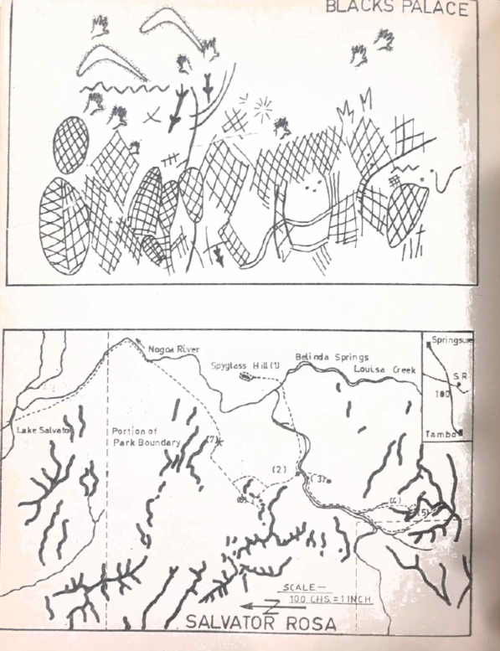

SALVATOR ROSA
Margot Shephard, Sybil Curtis
Salvator Rosa is the west-most of Queensland’s National Parks, lying approximately 90 miles south-west along the Great Dividing Range from the Carnarvon Gorge National Park. It includes a portion of the Great Dividing Range and foothills and the spring fed Nogoa River.
Access is gained from the Central Western Highway (actually an eroded dirt road) from a point about midway between Springsure and Tambo where the branch road to Cungella Holding (an outstation of Mantuan Downs) runs south for approximately 30 miles. Previously, it was also possible to enter the Park via Mt Playfair Holding but this road has deteriorated.
Cungella homestead is situated on the northern tip of, what was once, Lake Salvator, now artificially drained and used as grazing land. From here it is possible to drive to the southern tip of the “Lake”, which is 1 ½ miles downstream along the Nogoa form the Park boundary).
The party of four (E. Tesch, B. McCan, M. Shepherd, S. Curtis) travelled in a Faloon Station-wagon. The roads were dry, but a four-wheel drive vehicle would be necessary for wet conditions. At least five days must be allowed for travelling from and to Brisbane, and petrol consumption is high on the bad roads.
The general character of the country is a consequence of the sandstone strata which has been weathered, leaving between outcrops, sandy flats supporting sparse vegetation. The country would be waterless and barren except for a number of Springs which constantly feed the Nogoa River. The majority of these are seepages without a single point of origin for the flow: some rise unseen in the riverbed; others are apparently adjacent to the river, causing past bogs.
Louisa Creek, a tributary of the Nogoa, is fed by the Major Mitchell Springs (not seen but described as a seepage) and further downstream, the Belinda Springs, which have minor seepage areas and at last two point sources, which flow from weak bedding planes within the sandstone. Both springs are grotto-like and support a vigorous growth of fern. It was only adjacent to Belanda Springs that any quantity of water plants was seen; elsewhere in Louisa Creek and the Nogoa there are shallow sandy beds (average depth 8 inches) almost devoid of vegetation. This sand is mostly quartz, and the surface layers of the bed are constantly moving, wit occasional areas of knee-deep quicksand. After flooding, it is more extensive and considerably deeper, and was one of the reasons for draining Lake Salvator.
As indicated on the reference map, only a small portion of the Park was investigated, during a period of three days. Sid. McCorrie, overseer of Cungella, and his son, wanted to see the condition of the country, is offered to drive us in their Land rovers to Belinda Springs. Here, without packs, we set out for Spuglass Hill1 encountering, just to the south of the hill, a series of long wall-like outcrops rising to a height of 40 feet. The name “Spyglass” refers to a large hole about 30 feet in diameter in its crest. Without ropes we climbed from the east to the base of the hole. The isolation of this point gave a wide view and allowed easy relation of the terrain to the air-photos provides by the National Parks. None of the maps proved reliable in any respect, and the scale of the air-photos, of 100 chains to the inch, is questionable’; “real” distance being less than “photo” distance.
Returning to our packs, we headed WSW and selected the campsite2 shown. It was possible before nightfall to climb a nearby pinnacle3 and obtain further views into the southwest ranges, selecting a likely area for investigation.
The next day we visited this section, first followed the base of the white cliff-line4. The general erosion has cut almost vertical cliffs, on which are superimposed horizontal weathering along weak beds, which often result in overhangs. Later, we climbed from here, along the crest of a ridge, which intentions of circling around the range. While this gave superb views, particularly south towards the Carnarvons, heat and thorny vegetation made progress slow, so we abandoned the original plan and dropped down one of the gorges5 into a more western valley. In this region it would be impossible to become lost, as all cattle tracks and watercourses lead to the Nogoa.
To the north we noted some interesting rock formations which we call “the Three Sisters”6. These proved to be the end of a range which has been dissected by the wind into three enormous, isolated pinnacles.
On the last day in the Park, we walked from the campsite along the same route as the previous afternoon, but branched off before “The Three Sisters”, to cut around the end of a huge block, which was part of the “Sisters” old range. This involved climbing a small ridge, covered with “marbles” of cemented sand, weathered from the rock. Its crest gave a complete unforeshortened view of the three pinnacles.
To avoid the meanders of the Nogoa, we chose a more direct overland route back to the car. Quite accidentally, while walking through low country7 we noticed some very faded stencilled hands on a low sandstone outcrop. Further search revealed more of these, but al were weathered and faint. During this search a grave was discovered in a small cave (4.3.3. feet), above give feet above the ground level. We carefully removed the sticks and pieces of flat stone to expose the remains of an Aboriginal body which originally had been bound in a crouching position. Bark of similar wrappings had disintegrated, and the bones themselves were very old and fragile. The head had been displaced, so probably the grave had been previously disturbed.
As time did not permit further foraging, we walked to the Nogoa, and paddled back to the car, to leave next morning.
We say only a fraction of the Salvator Rosa park, which is itself only a fraction, characteristic of the whole area. form the road some of the area appeared more spectacular than the Park, but has the disadvantage of being practically waterless. Because of its inaccessibility, Salvator Rosa will long remain a little known National Park, but for those who have the time and energy it provides an interesting and relatively unexplored area.
BLACKS’ PALACE
A further pace of interest in this district is Blacks’ Palace, which consists of decorated sandstone cliffs rising out of a sandy plain. It is reached by travelling 42 miles from Tambo along the Alpha-Tambo road, and then 15 miles on a winding bush track on Lisgool Station. Details may be obtained from Hamilton’s in Tambo.
The paintings and carvings extend along the base of the cliff for about 100 yards, reaching a height of 10 feet. The wind-scoured caves, between 15 and 30 feet above the ground, have been used for burials.
The paintings show more variety than those of the Carnarvons, and are denser, having been painted over a number of times. Besides the typical stencils of hands, feet, and boomerangs in red and yellow ochre, there are areas of ochre and white clay line drawings. The most common are zigzags, cross-hatching, double rows of vertical lines, and combinations of these. In the undisturbed sand at the base of the cliff were tracks of bids and snakes. Aboriginal artist has observed similar markings and had also included them in the paintings and carvings.
The burial caves are relatively deep and narrow, and would be inaccessible except for notched poles leading to the mouth of each cave. They had all been plundered and although fragments of bark wrapping were mixed with the sand, there were no skeletal remains. There are further cliff faces suitable for painting, but most of them are concentrated on this one exposure directly below the caves.
Much of the cliff face has been desecrated by man, but it is certainly worth visiting if traveling through the district.

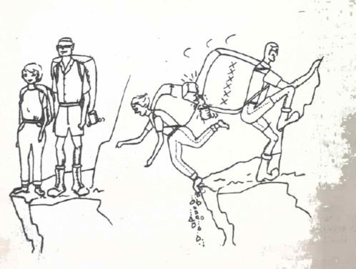
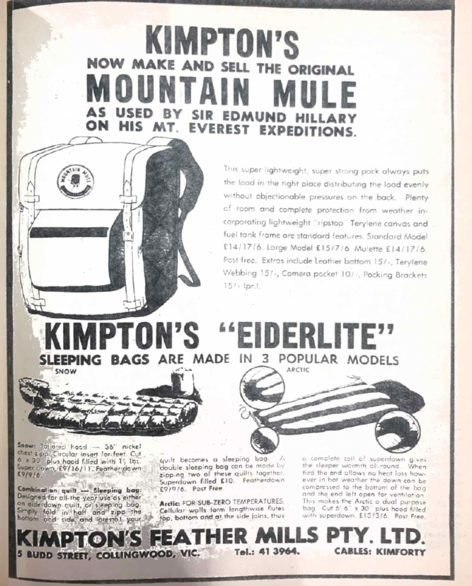

A BED-TIME STORY
Bronwyn Day
We had been tangling with particularly wet and frustrating rain forest all afternoon, and now, as we were sitting around the dying embers of the fire, it was Eddy, puffing away at an extremely offensive pipe, who said meditatively: “There’s no doubt about it, this is the best … way to spend a bushwalk!”. We could but agree with him. But later that night, as I lay shivering dejectedly within the folds of a cold and sodden sleeping bag, heavily wishing for the dawn, I hastily revised my previous opinion.
What strange twist of character makes me even think of exchanging the comfortable security of the homely bed for this? To sleep the disturbed sleep of the uncomfortable, but exhausted walker, under a minute piece of smelly plastic pitched precariously about two feet above ground level!
Indeed, now I know why certain people are always very reluctant to make a move in the direction of their sleeping bags. they are the noble few who always manage to get pushed to the outside of any sleeping group. It seems that most bushwalkers have an outside of any sleeping group. It sems that most bushwalkers have an outsize sense of hospitality. Their tent can hold twice, three as many as for what it was originally designed. This is, admittedly, a subterfuge to achieve maximum warmth at the cost of a minimum of comfort, but is a manouvre perfectly legitimate, provided you are not one of the aforementioned “noble few”. This packing of tents, of course, leads to a careful alignment of bodies, and abhorred is the person who indulges in any excess movement cause by lurid dreams, projecting rocks, or the finding of any truly monstrous creatures with numerous appendages and feelers “at least ten inches long!”.
The varied characters who inevitably crowd under the same shelter can affect considerably the night’s rest. Imagine the usual desultory chat which always occurs after the intensive getting-into of sleeping bag plus interlining, and settling down for the night, centering around possible ways of achieving proper sanitation for Mt Barney. It surely would have been a most fascinating discussion, if only I had remained awake for it … pity! Those who desire a nocturnal snack at some early hour of the morning are also to be commended, provided they elect to drag their bodies out into the frosty air to find the goodies, whilst their companions wait in the eager anticipation of being offered such delectables as peanuts and chocolate. It is like having breakfast in bed, without the fear of spilling food on the bed-clothes. Those who tell good yarns, sing sweet lullabys softly – very softly – to themselves, or who can see the ludicrous side of any disaster such as the agitated sound of “you know, I think the water’s coming in … Good grief! This tent’s not waterproof. I knew I shouldn’t have left it lying under the house for the last three years!” … these are also welcome.
Speaking of tents, they are an interesting part of the Queensland bushwalker’s equipment. Not having to face the rigours of intense cold, snow or sleet, the walker in this State (or am I speaking only for a certain proportion of them?) is fairly casual about it all. Usually, he doesn’t possess the elaborate kind unless he is contemplating a trip south. In fact, he confidently expects that any old strip of plastic strung over a long piece of string and anchored down with rocks will withstand the heaviest downpour of rain, which will automatically occur after every weather prophet has confidently forecast a completely fine weekend. As you have no doubt learnt through experience, this faith in both tent and weather prophet is all poppycock. Just as well the weather is a thing to be gambled with. It is the factor that colours tour reaction to a return to civilization at the end of the walk most, and it also has a bearing on the sort of figure you cut before family and friends the next morning.
It is a most interesting spectacle to come upon the campsite of the walker I am speaking of. Contrary to sensible practice, after mediating long over his breakfast he is adamant, that he must reach a certain point before the end of the day’s walking, and with a fanatical determination he does so! This involves, naturally, floundering willy-nilly up creek or through what seems impenetrable jungle, or up and down virtual cliffs at a time when all level-headed and considerate people have installed themselves in some delightful campsite. After a while, the feet automatically follow one another and the prospect of the sheer unexpected, which is always present at night, just doesn’t have the same power of exciting anyone as it would during the day. Finally, a possible camping site is reached, together with he first intimation that rain is imminent.
It doesn’t really matter where that tent is pitched. If you are tired enough your body will automatically come to terms with any sharp projections – strange, how they are always in the region of the hips, the small of the back and the ear. As long as the tent isn’t pitched on more than a thirty degree angle is perfectly adequate. The prevailing philosophy at this time is “I’m positive it won’t happen again – not after last time”. The vision of “last time” is hastily banished from the mind. Optimism is a trait to be cultivated for moments like these!
The next time you are occupying a tent where there is more water inside than outside, console yourself with the reflection that others are in the same predicament. A perverted enjoyment can be obtained through watching the naked misery on the faces of your companions. This is the moment when you may also indulge in the cheering pastime of fervently hating anything and everything – the weather, the tent, your friends who are still warm and dry. Anyway, it all helps to pass the time away, and while you are all grumbling about “how I hate walking when it’s raining!” remember that a horrible night in the rain is just another of those Joys of Bushwalking.

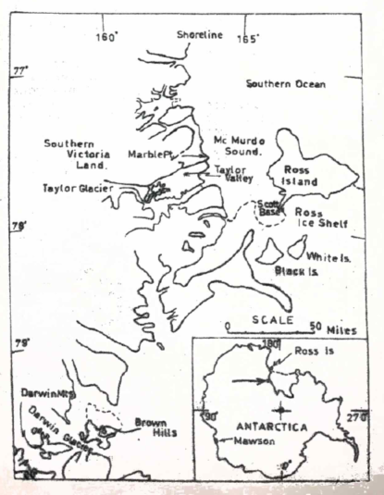

V.U.W.A.E.
Tom Haskell
Since 1958, Victoria University of Wellington has sent nine expeditions to the Antarctic to work in the dry (ice free) valley system to the west of the Ross Ice Shelf and McMurdo Sound. In this area, a programme involving mapping of the Pre-Cambrian and Lower Palaeozoic metamorphic and intrusive rocks, Upper Palaeozoic sedimentary rocks, Mesozoic intrusives, Tertiary and Recent morains, and study of temperature and salinity conditions of the numerous superficially frozen lakes of the area, as well as topographical surveys, has been continued.
The sixth of these expeditions, which have become known as VUWAEs, was to work in the region of the Darwin Glacier, 200 miles south of Scott Base. The party comprised Ian Willis, a member of two earlier expeditions, as leader; Prof. Charles Rich of Bowling Green University, Ohia, as deputy; and Jim Kennett, Warwick Prebble, Gill Smith and myself. Apart from Charlie, we were all senior students from the Geology Department.
Prof. R.H. Clark and Ralph Wheeler (VUWAE 3 and 4) flew over the region the summer before to get some idea of what was available. Prof. Clark, head of the Geology Department, was the initiator of the first VUWAE, and cannot be praised too highly for the job has done in organizing and assisting the whole series of expeditions.
Charlie and Gill left New Zealand early in November 1962, and carried out a further reconnaissance to find a suitable landing site for ski-equipped DC. 3 supporting aircraft. The rest of the crew followed about 10 days later in a C124 Globe-master, a trip of 11 ½ hours, covering 2,500 miles. We landed on Williams Air Field, cut in the 20 foot thick floating ice of the Ross Ice Shelf, and with the other 10 New Zealanders on the flight, and equipment, covered the last few miles across the Shelf to land at Scott Base in Land Rover, weasel, and tractor sled.
We stayed in the comfort of the interconnected buildings for a few days to finally check and pack equipment, and visit for the American Base (McMurdo), and Scott’s Hutt at Hutt Point.
Basically, equipment consisted of:
Wearing: string singlets, long johns, woollen shirt and longs, “freezer” jersey, down jacket, ear muffed cap, wool gloves, windproof anorak, trousers and gloves, two pairs of socks, and normal, but heavy, boots.
Sleeping: Inner and outer sleeping bag on blow-up mattresses.
Living: Scott-Polar tents – double walled pyramid type, and smaller, light floored meads, kero primuses.
Eating: Dehydrated foods, chocolate, biscuits, etc., packed in 40 l., 20 man-day ration boxes.
Dragging: Mountain Mule packs, one 14’ long wooden manhauling sledge, and light, fiberglass “banana” sledges, as well as a powerful “sledge” radio set for communication with Scott-Base, and several low-powered field sets, and the usual equipment for climbing on ice.
On November 21st, two DC.3’s of the US Air Force squadron V.X.6 were loaded, and headed off. Unfortunately, the area was cloud-covered, and we had to return; however, next day we landed at 2,000’, at the western edge of the Brown Hills. The weather was fine and clear, but a “white-out” was not far off. The ‘planes were unloaded with all haste, and took off using Jato (jet assistance). The fine snow lifted by the rockets did not settle, and, in a white-out, we toasted our safe arrival.
The plan was to establish base camp in the heart of the Brown Hills, 5 miles and 1,000 feet down to the East. Next day, 3 sledges weighing about a ton, with tents, radio, etc., were man-hauled 15 miles down to the Darwin Glacier, and round it to the valley floor. The gear was belayed off the steep edge of the glacier, and cap set up near a frozen lake a quarter of a mile off. During the process of sorting, hauling and re-pitching, we made use of the 24 hours’ sunlight and almost saw the whole circuit. Further food was back-packed down from the strip, using a direct overland route. The party formed 3 teams, 2 geological and one glaciological (Charlie and Gill).
Working on a radial pattern, the vicinity of base camp was soon covered, and fly camps were set up by back-packing over rocks and man-hauling on the glacier. For these trips the light banana sledges and the mead tents were used. In the far west of the area, a small patch of infolded metasediments was found – the only relief from the widespread granites. Stakes were placed on the Darwin Glacier to determine its rate of flow, and were sighted in to survey stations. The weather was very good, though some “guess and by God” compass navigation was necessary in the occasional white-out.
The next stage – the crossing of the Darwin Glacier – was contemplated from Bastion Hill (6,000’). The extensive crevassing was beyond our scope, and air support was called up. Due to poor weather, this was ten days in arriving, so the odd game of ‘cricket’ was played – furthest south ever.
The Darwin Mountains were higher than the Brown Hills – 4-10,000 feet as against 500-6000’, colder – average – 5 degrees Celsius against – 2 degrees Celsius, with minimum on Midnight Plateau, the highest area of about – 35 degrees Celsius. Using fly camping, a sequence of Devonina Sandstone and Permian Tillites, and Coal Measures (wit a good Ganamopteris flora) intruded by Triassic dolerites was mapped.
Our light loads were meant that all the “Christmas cheer” was on the other shore, so we elide on lemon crystals and a yarn with other field parties several hundred miles to the North – Scott Base, Cape Royds, and anyone else who tuned in.
The party re-crossed the Darwin, packed up, hauled back to the ski strip, and were back at Scott Base on New Year’s Day.
This left a considerable amount of the field Season untapped, so the last gaps in the dry valley geological mapping – Taylor Valley, 40 miles to the N.N.W. of Scott Base 0 was given full attention. Warwick and I accompanied Dr Colin Bull, now Ohia State, ex VUWAE 2 and 4, to do a gravity survey the day after we got back to Scott. Base camp was set up in the middle of the Valley, near Lake Bonney, at the snout of the Taylor Glacier.
The valley is about 45 miles long, runs W.N.W., opening onto the sea at one end, blocked by Taylor Glacier at the other. Typically “U” shaped, its walls rise to about 6,500’ with hanging glacier between the peaks. The area is quite hot – average January temperature + 5 degrees Celsius.
The gravity survey was conducted along the lower two-thirds of the valley. We flew back to the sea, then slogged up the middle, the whole operation taking about 36 hours of continuous travel. Meanwhile, the others had established 3 other food dumps at ten mile intervals along the valley. For all these operations, the Americans provided helicopter support, which saved much time and energy. The geology and glaciology of the valley was covered by back-packing the meads and small radios between food dumps, and then radiating from them. We finally reached an unmanned US standby base, Marble Point, at the sea, finishing the field programme. Two more chopper flights took the crew and their gear to Scott and hence, home, a few days later by Super Constellation and Hercules.
The whole expedition depended on the expensive, but willingly given, support of V.X.6. We were almost grateful to the Americans for this service. It also provides an excellent example of the type of real international cooperation common in Antarctica. The main results of the expedition were about 1,000 square miles of territory mapped geologically, glaciologically and topographically, in detail. Less tangible results are the friendships made, and the lessons learned in cooperation.
The Antarctic is a fascinating land. The beauty and contrast of its mountains, glaciers and ice sheets, viewed on bright day in a perfectly clear atmosphere, is indescribable. The absolute silence of a still day in these surroundings leaves an impression of humbleness. The continent moves at its own pace, be it the irresistible creep of a glacier, the slow advance of a white-out, or the rear and buffet of a blizzard. You must learn to ft in with the pattern, so that everything you plan has the unspoken condition attached “Antarctic factors permitting”.

---
In Bushwalking, a man is prepared to part with half his food to get the other half cooked.
----
Do your feet smell? Does your nose run? Then you are made upside down.

A RETURN TO THE CARNARVONS
Geoffrey West
Inspired by a highly successful onslaught of the Carnarvon Gorge by this Club last year, the Committee arranged a similar trip for this year’s May Vacation. As the result of a slight embarrassment incurred on the previous trip, the ‘bus company insisted on providing its own Driver – and on the leaving date, we awaited His arrival with great curiosity.
Saturday, 22nd
Well, we met Buster the driver, a pleasant, stocky individual with a dry sense of humour and three bottles of rum. On the back seat of the ‘bus, some of us noticed an extremely large carton; this was the collective good supply of six people, bought collectively on Friday from the Bash and Carry, where it presumably occupied several counters. Singing commenced with “Away, Away with Rum, by Gum!” – but Buster pretended not to notice.
We reached Roma at nightfall and telephoned the butcher at Injune to check that he would open up for us on Sunday; this step was essential, because Buster had suggested: “The butcher might be on the booze, or something”. We proceeded the 60 miles to Injune, and after a harmless tour of the town which included overloading a 6d – in-the-slot mechanical Kangaroo, demanding to see the Sheriff, insulting the theatre proprietor, singing the Rum Song outside the Pub, and trying to crash a Fancy Dress Ball, we went to bed in the middle of the showground.
Sunday, 23rd
At 12.30 am we were awakened by a loud crash, the splintering of glass, and much drunken abuse. A one-eyed Holden then drove onto the showground – we all got ready to run, then they left us. At 1.30 am, a car was driving madly round and round the grandstand, in which some of our people were encamped. At 2.30 am, I thought I heard fireworks rather close by – after that I managed to sleep.
In the morning, we learnt some interesting facts; (1), the car driver was none other than Harry, the Butcher; (2), I had not heard fireworks – they were shots; (3), one of the “tight” passengers had looked at us and exclaimed: “Gee, those anthills were’nt there last week”. We also learnt some interesting gossip about locals like Pearl, who was just wild about Harry.
After breakfast, we were visited by three semi-sober types in a white V.W. one was heard to say: “They’re Uni. Girls, but they’ll do”. The second said over and over again “Well, anyway, have a good time”. Earlier, Jim had mentioned a character who had told him he was deaf, and this had puzzled him no end. Realization came when he heard the third character yelling out: “Sex makes you deaf – you’re deaf”.
These types seemed attracted by us (strange) and some difficulty was had in evicting them from the ‘bus.
The ‘bus reached Carnarvon Gorge without further events, and followed the newly-completed road from the C.W.A. Hut¹ to the base³, where some tourist facilities had been erected. Our party of six left base at 3 pm and headed for a campsite opposite the Amphitheatre⁶, which we visited (probably the most impressive side gorge). As a result of an Easter Bunny incident on a previous trip, we spent most of the night shouting into the darkness! “We know you’re there, Jim – you can come out now”.
Monday, 24th
In the morning, we visited Fairyland⁷, and Potts Point⁸ – (yes, our Don!). we wared waist-deep into Fairyland and saw the side-cavern; Jennie lost her footing and came into rather more intimate contact with the water than the rest of us.
After lunch, we visited the Art Gallery⁹. Other parties being camped at the swimming pool¹⁰, we went on the Cathedral Cave¹¹. That night, under the expert supervision of Pyromaniac Chief, Ian, we gathered and set fire to several hundredweight of dead palm fronds.
Tuesday, 25th
Leaving late, we followed Boowinda Gorge to just above the fork, and thence climbed to Battleship Spur¹². Pulse checks revealed a record 170. We had lunch and found a lookout which gave excellent views of Region¹³ on the Map. We then proceeded along the Great Dividing Range¹⁴ and down a ridge. Phil. appeared entranced by a speck on the horizon that he thought might be Mt Barney (350 miles away).
Nightfall found us on a ledge above Boowinda Gorge;¹⁵ a safe descent could not be achieved in the darkness and so we were forced to stay the night. After I was presented with a Gold Award for leadership, our party settled around a fire, and talked and sang for 12 ½ hours. At a quarter past each hour we stood up, sang appropriate Anthems and rotated one place; this proved particularly effective for keeping people awake, and form it our “Mining Anthem” (God Save our Gracious Ming) evolved, and was perfected into a round by morning. (For those among us who are not politically knowledgeable, King Ming was formerly Viscount sir Robert Menzies, K.T.). Food consisted of 4 prunes, ½ mouthful of water, and 1 biscuit, each.
Wednesday, 26th
After walking around numerous side-gorges, we found a crevice which offered an easy way down. A lookout¹⁷ interested me, and I decided to lock at it again later. Warwick, Jim, and Dennis looked aghast as we appeared above them, clambered madly down a slope, and splashed into the swimming pool, singing “We Have Overcome”.
We had a restful day, and retired early.
Thursday, 27th
We arose late, and headed up the main gorge to Nabooloo Gorge, which impressed us. Rosemary told us of a “transparent hole” which we investigated. After lunch, we returned, with packs, down the Main Gorge. Jennie, Phil., and I investigated the lookout that had interested me, and which we considered worthy of the name “Mt Ming”.
I highly recommend this lookout, which gives excellent views of the Hairpin Bend. Parrabooya¹⁸, Consuelo Tableland²¹, and the top of Sky Island (e.g.,¹⁹) untrod by man or beast. Echoes are excellent. Mt Ming may be reached from the Main Gorge in 10-20 minutes by way of the crevice immediately South of it.
That night, we camped opposite the entrance to Violet Gorge⁵, and Hellhole⁴.
Friday, 28th
We proceeded up Hellhole Gorge, climbed the slippery log under the waterfall, and found that the creek had been dammed at the entrance to the cavern. We had to swim through the last part of the Cavern-Brahh – but the increased depth prevented us from seeing Hellhole itself. We returned down the waterfall in the traditional manner, i.e., we jumped 8 feet into 4 feet of icy water.
Returning, we proceeded to a campsite on a sandy strip in the midst of dense pinetrees below Boolimba Bluff²². With smoke wafting from our fire in the middle of the pines, this gave the impression of a Canadian Landscape.
That night we had an elaborate dinner. The stewed apricots were hot and so Jeanette suggested we “put them in the shade”. After the meal, Rosemary was presented with a Gold Can-opener Award for Cooking.
Saturday, 29th
Our trip was coming to an end, our scheduled time of departure from the Carnarvons being noon; however, we had time to have a crack at Boolumba Bluff. The climb is achieved via a gully on the eastward side. The view from the top is excellent, and includes an extremely wide area including Kooramindangie Plain and the open country east of the Gorge. From the top we communicated with Buster who appeared anxious that we come down quickly, and so we obliged.
By methods diplomatic and devious, our six secured the back seat for the return journey. During the following hours, we gave a recital of all the songs we had written on the trip, but these did not meet with the success we felt they warranted; this fact we particularly noted after the encores! We were eventually suppressed with Gab-stoppers surreptitiously supplied by Doug.
We decided to sleep at Condamine, which was as far away from Injune as we could get: and so we supped at Roma. As we strolled after tea along its main street after our Conga down it, we were conscious of three young lads, in a Falcon Ute doing S-turns, yelling out “Good-day”. Indelibly written in my mind’s eye is an image of six bedraggled bushwalkers, their noses pressed against he glass, singing “How Much is that Doggie in the Window?”.
Sunday, 30th
Well, we drove, and ate, and sang, and slept, and talked, and rubbished people, until we got back to Brisbane. The beard contest remained undecided, since we couldn’t determine whether the Singe test of the Weight test was the more appropriate. The last thing I remember is that a tourist lady in Elizabeth Street, who snuck up intrepidly and photographed us as we emerged from the ‘bus.

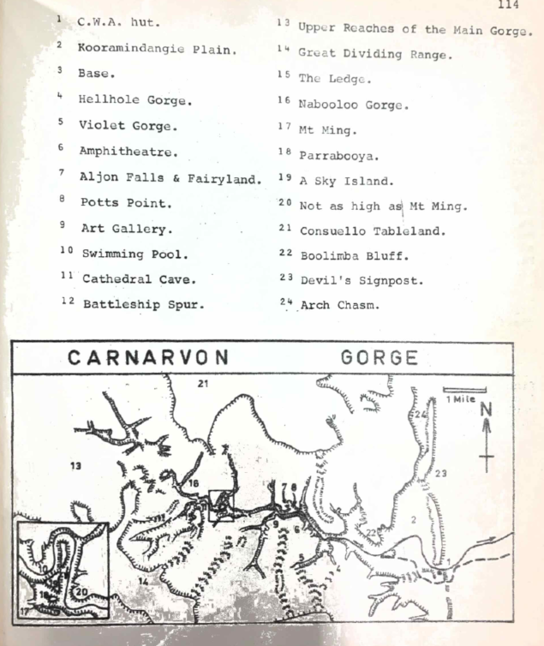

PARTING THOUGHTS
Jenny Nielsen
In a few weeks I am going to the ugly concrete jungle of New York – to the land of thoughtless destruction of all things natural, so deplored by Eddie Hegerl. There is so much that I have enjoyed here as a bushwalker – countless fires until late into the night, climbing the Story Bridge at 1 am, the phosphorescence in the Tweed River in the dark when the water was brilliantly clear, and jumping over the waterfall into Fairyland in the Carnarvons. These things I shall miss in my strange circumscribed new life – a life ruled, so the Foreign Student Advisor tells me, by enormous coast, snow boots, central heating too intense for comfort, rain, strong winds and searing summer heat. When I am engulfed in the horrid reality of the New York climate, I’m sure I shall wonder whether the water in siphons deep underground in Jenolan Caves in midwinter or in Barney Creek at midnight in July was really cold at all. my memories, now sharply delineated, of the discomforts and pleasures of bushwalking in frost, cyclones, rain forest drizzle and chilly winds, will merge into an idealized melee of happy memories. Hopefully I am taking my pack, tent and battered old cooking pots. Perhaps I shall be able to use them.
Reading Eddie’s harsh words about American civilization and ugly Brooklyn has made me wonder again why I am off to New York with any alacrity at all. I know nothing of what I shall find and all this is mere idle speculation. So in the meantime, I am savouring more keenly he pleasures of walking, climbing, caving and diving in this lovely climate. Strange how it takes an imminent departure to evoke such appreciation of what I’ve enjoyed for years.

